This is how negative gravitational field came to existence (Anti-gravity force, Dark energy, The theory to explain accelerated motion of the galaxies in the universe), and inversion of the gravitational field
Mohammadreza Tabatabaei
contact@ki2100.net
Universal law of gravitation: If an object is launched from a relatively high altitude, paralleling to the circumference of the planet, under Centripetal Force will follow a curve like path, and eventually will fall back to the surface of planet. If the velocity of the object is high enough, will follow a perfect orbital path around the planet according to the figure as indicated below:
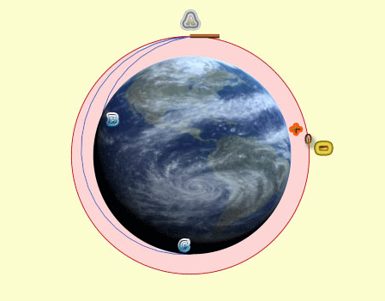
If the projectile object now is presumed to be stationary and the planet supposedly is revolved at the same angular velocity, what will happen?
With reference to relativity theory, since the laws of physics are the same for all coordinate systems with fixed speed , then it won't make no difference whether the object orbits around the planet, or the planet rotates at the same angular speed and the object remain stationary. In another word the said study for the observers, on the planet and the object will remain the same. In both situations the object will reach weightlessness, and will never fall back to the surface of the planet. The shape of the orbit is shown as a circle in the picture above and if the distance between the object and the planet surface is reduced, gradually in time the object (the projectile) will fall to the surface of the planet. The area within the circumference of the orbit is called the Positive gravitation area and if the distance between the projected object and planet is increased gradually in time, it will be repelled from the planet. The area outside of the orbital circumference is called the Negative gravitation area. If we consider the planet to have a rotational speed equal to the velocity of the object, both areas will include the all of objects, and if we assume the object is to rotate around planet, both areas will include only in the object. There is also another side to this; meaning, if the angular speed of the object or planet is to be greater than what is necessary, then the object will be repelled from the planet at once. See the image below:
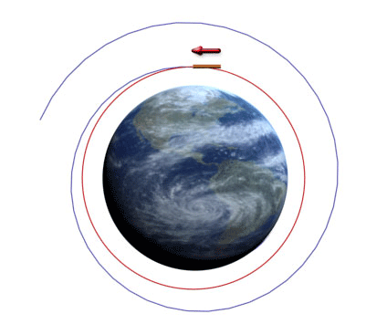
Justification for Accelerated Motion of the Galaxies in the universe:
The linear speeds of the entities near the nucleolus of galaxies are measured to be about one third of the speed of light, thus we can conclude that all entities outside of the nucleolus of galaxies are within the Positive gravitation field of the Galaxies, at the outer edge of the Galaxies a Zero gravitation field, and outside of this area it will be Negative gravitation area; in other words, all galaxies in outside of the Positive gravitation area, and their zero, have Anti-gravity force or Negative gravitation field which by this force can reach motion and accelerated velocity in the cosmos. This is called the Dark energy and to this date we have been unaware of its nature. Since the time of Newton some of the physicist believed that for the Centripetal Force which is an attraction force and is to collapse the universe there is a repulsion force which prevents the universe from falling apart, thus the universe remains intact. Anyway, neither those who object to the immortal universe theory had a proof, nor those who supported the theory could prove their point. This is a gravitation Repulsion force, of the outer galaxies, and has nothing to do with the inner sides of the Galaxies.
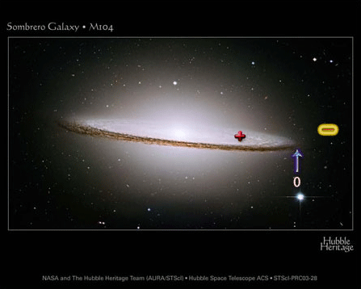
This phenomenon of course has been noticed only at the recent times and seems to be difficult to recognize, because our expectation of the gravitation is the attraction force, and not the repulsion force, and this newly recognized phenomenon can be explained by all Universal Laws of gravitation, laws of Relativity theory, and also can be defined by Mechanical Quantum Physics.
In order to prove our point based upon the existence of Negative gravitation (Anti-gravity force), we will formulize it in equations as below:
$$\begin{aligned}f=m\frac{v^{2}}{r} \\ F=\frac{\text{GMm}}{r^{2}} \\ F=f⇒m\frac{v^{2}}{r}=\frac{\text{GMm}}{r^{2}}⇒{\text{mv}}^{2}r^{2}=\text{GMmr} \\ v^{2}r=\text{GM} \\ r=\frac{\text{GM}}{v^{2}}\end{aligned}$$
As we know in the equations above f is the centrifugal force of the object, m mass of the object, v linear speed of the object on orbit, r the radius of the orbit which is the distance between object and the center of the gravitational field (planet), F The attraction force between the object and the center of attraction force of the planet, G constant of gravitation, and M is the mass of the gravitation center (planet). In order to obtain a continuous orbital motion between the object and around the center of the gravity must have F=f for which we can calculate the distance r and the velocity v. We can now assume to have the object stationary, and to have the center of the attraction force to rotate at the same angular speed, as if the object was to travel around the planet. In order to attain the equations, one must substitute the linear speed of the object with the angular speed of the center of the gravity in the equation:
v=ωr
As we know ω is the angular speed (Radian per second 2pi/s)
$$\begin{aligned}r=\frac{\text{GM}}{v^{2}}=\frac{\text{GM}}{{\left(ωr\right)}^{2}}=\frac{\text{GM}}{ω^{2}r^{2}}⇒ \\ \text{GM}=ω^{2}r^{3}⇒ω^{2}=\frac{\text{GM}}{r^{3}}⇒ \\ ω=±\sqrt{\frac{\text{GM}}{r^{3}}} \\ r^{3}=\frac{\text{GM}}{ω^{2}} \\ r=\sqrt[3]{\frac{\text{GM}}{ω^{2}}}\end{aligned}$$
It is amazing that ω or the angular speed in this equation can be either positive or negative. In other words, the rotation of the center of the gravity from an observer or observer's view point can be clockwise or counter clockwise, but the radius or the distance of the object with the center of the gravity will always remain positive and no one can use these equation claiming a negative length or negative dimension in another imaginary universe. (Meaning, an anti-universe or anti-world, negative dimension and……). These equations will indeed deny the existence of white holes and an entry to another world.

To design a very important problem in physics regarding cosmic Physics:
There is a neutronic mass as much as five times the mass of the sun. If the angular speed of this mass is to be 500 Radian per Second, what are the:
1. Range of the positive gravity field
2. Orbit of the zero gravity field
3. Range of the Negative gravity field
$$\begin{aligned}G=6\text{.}\text{672}×{\text{10}}^{−\text{11}} \\ M=5×1\text{.}\text{99}×{\text{10}}^{\text{30}}=9\text{.}\text{95}×{\text{10}}^{\text{30}} \\ ω=\text{500}×2π=\text{3141}\text{.}\text{59265} \\ r=? \\ r=\sqrt[3]{\frac{\text{GM}}{ω^{2}}}=\sqrt[3]{\frac{6\text{.}\text{672}×{\text{10}}^{−\text{11}}×9\text{.}\text{95}×{\text{10}}^{\text{30}}}{\text{3141}\text{.}{\text{59265}}^{2}}}=\text{40668}\text{.}\text{65329m} \\ r=\text{40}\text{.}\text{6686km}\end{aligned}$$
Answers:
1. The range of the positive gravity field is less than 40,668 Kilometer
2. The border limit of zero gravity field is the 40,668 Kilometer orbit
3. The range of Negative gravity field is from the 40,668 Kilometer radius to infinity. In fact range of the black hole's gravity field is infinite, but it's gravity acceleration after the 40,668 Kilometer will be negative. The said black hole's negative gravity acceleration can cause and produce a self-speed and self-acceleration. To this date, some black holes are identified and tracked to travel at the speed of 4000 kilometers per second.

This is the first time than such subject is brought up, and analyzed by the science of physics, and now we can easily notice three important subjects:
1. How come not all the cosmic entities are consumed / swallowed by the black holes (not pulled toward)?
2. What is the main reason behind the accelerated development of the universe?
3. In order to explain the development of the universe, there is no need to present or to admit the Big Bang theory, because the said development can be explained easily.
$$\begin{aligned}F=\frac{\text{GMm}}{r^{2}}=\text{mg}⇒g_{+}=\frac{\text{GM}}{r^{2}} \\ f=m\frac{v^{2}}{r}=\text{mg}⇒g_{−}=\frac{v^{2}}{r} \\ g_{f}=g_{+}−g_{−}=\frac{\text{GM}}{r^{2}}−\frac{v^{2}}{r}=\frac{\text{GM}−{\text{rv}}^{2}}{r^{2}} \\ g_{f}=\frac{\text{GM}−r{\left(ωr\right)}^{2}}{r^{2}}=\frac{\text{GM}−r^{3}ω^{2}}{r^{2}}\end{aligned}$$
g, g+ and g- are respectively the gravitational acceleration, the gravitational acceleration of attractive field and retardation resulted from the centrifugal force. gf is the difference of these two accelerations and consequently it is the final acceleration. If the final acceleration is positive the gravitational field will be positive too and if negative, the gravitational field will be negative and the attractive force will be changed to anti attractive force.
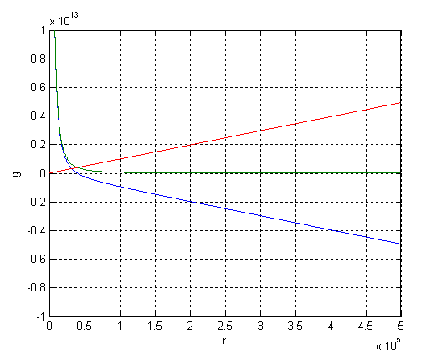
The above diagram is related to the previous example, the green curve and red vector respectively show the decrease and increase of gravitational acceleration in proportion with increase of distance from the field center and the blue curve and vector show the difference between them.
To analyze the subject from the "Relativity theory" view point:
If we consider a point anywhere around the center of the gravity filed, we can assume allocate some energy for the given point or the place.
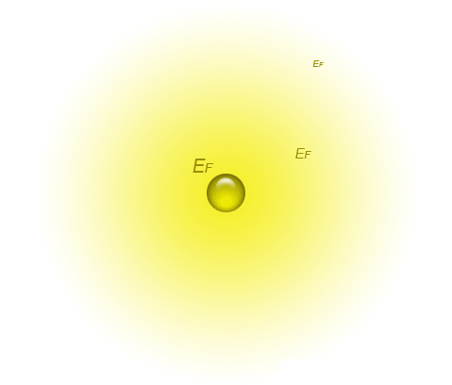
As we already know, energy and mass are equivalent, therefore, we can calculate the mass equivalent of this energy:
$$\begin{aligned}\left\{E={\text{mc}}^{2} | \right.\left\{E=E_{f} | \right.\end{aligned}$$
E energy, m mass, c light speed, Ef energy of the gravity field in any assumed point, and mf is to be the mass equivalent of the gravity field energy in any assumed point. Obviously the said mass is produced by the gravity field due to the rotation by the center of the field have begun to revolve, and defiantly causing a centrifugal force. For which to formulate it to an equation, we use the same approach.
$$\begin{aligned}F=\frac{\text{GMm}}{r^{2}}=\frac{{\text{GMm}}_{f}}{r^{2}}=\frac{\text{GM}E_{f}c^{2}}{r^{2}} \\ f=\frac{v^{2}}{r}m=\frac{v^{2}}{r}m_{f}=\frac{v^{2}E_{f}c^{2}}{r} \\ F=f⇒\frac{\text{GM}E_{f}c^{2}}{r^{2}}=\frac{v^{2}E_{f}c^{2}}{r} \\ \frac{\text{GM}}{r^{2}}=\frac{v^{2}}{r}⇒r^{2}v^{2}=\text{GMr}⇒{\text{rv}}^{2}=\text{GM} \\ ⇒r=\frac{\text{GM}}{v^{2}}=\sqrt[3]{\frac{\text{GM}}{ω^{2}}}\end{aligned}$$
We will finally reach the same results as we have before. Now we can calculate for the mass equivalent of the gravity potential energy. It is as follows:
$$\begin{aligned}m_{f}=\frac{E_{f}}{c^{2}} \\ U=E_{f}=\frac{\text{GMm}}{r} \\ m_{f}=\frac{\frac{\text{GMm}}{r}}{c^{2}}=\frac{\text{GMm}}{{\text{rc}}^{2}}\end{aligned}$$
Evaluation of the subject from a Mechanical Quantum view point:
As we know Photon in Mechanical Quantum is considered the boson of the Electro Magnetic Field, which has both energy and mass, since it has a speed (c) it will have momentum too. If Mechanical Quantum theory view point is assumed to be right about gravitational field to be of particle types, and particles to carry gravitational energy or force weigh as much as gravitons, then the said gravitons under certain conditions, equivalent to their own energy will have mass and momentum, and as the center of gravity field revolves, they will begin to have either a swirling (Helix cal) type of spin, or circular spin. By increasing the radius and the circumference of the gravity filed (the orbit on which gravitons turn), the linear speed is increased; thus, the centrifugal force will increase as well, and finally the vector direction of gravity force of the gravitons (gravitational force vector) is reversed, and the gravitational force to negative gravitational force, and the attraction will reverse itself to repulsion, or it will just change. In brief the attraction force will be toward the center of the field (Gravity center of the mass) will convert to repulsion force, or escape from the center. Apparently to derive the same physical equation, we will achieve the same results as we did before, because in these equations the mass of the object, or the graviton, and……..will be omitted the both sides of the equation.
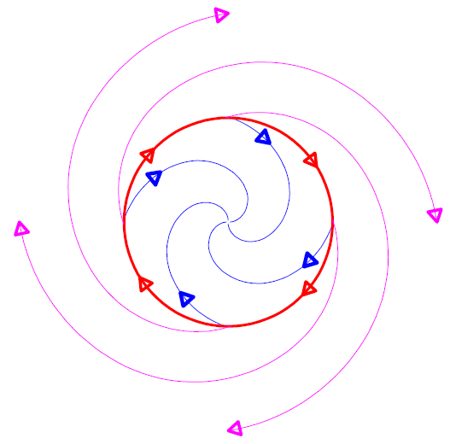
Blue swirling (helix cal) motions inside of the red circle is for the behavioral force of the positive centipede at the center, the red circle is for the behavioral force of the zero / neutral centipede, and the violet curvatures outside of the red circle is for the behavioral force of the negative centipede outside of the center, indicating the presumable gravitons.

