The space - time expansion arises of the big bang theory an unjustified explanation to develop the universe

Note: in this chapter, we’ll present a new definition of space-time continuum.

To clarify the subject, we’ll start with a simple example. Suppose that we have two metal wire with the same alloy. One of them has 1 meter long and the other has 10 meters long at 30° Celsius. It should be state that, the 1m long wire is divided into 100 equal sections (100cm). Now, we transfer the wires to an imaginary planet that the temperature on the surface is more than 30° which leads to the expansion of wires so that 1m long wire will increase to 101cm and the 10m long wire will become 10m,10cm. in this situation, if we measure the second wire with the first one, we’ll obtain the 10m long again, because:
$$\begin{aligned}\frac{m_{0}}{T_{0}}=\frac{m}{T}=\frac{Δm}{ΔT} \\ \frac{1m}{\text{10}m}=\frac{\text{100}\text{cm}}{\text{1000}\text{cm}}=\frac{\text{101}\text{cm}}{\text{1010}\text{cm}}=\frac{1\text{cm}}{\text{10}\text{cm}}=0\text{.}1\end{aligned}$$
m0 is length of 1m wire and T0 for 10m wire at 30°, whereas m is the length of the first wire and T is the length of second wire in the hot imaginary planet. ∆m, ∆T will show the length differences (expansion values). It’s clear that, to measure the expansion of the second wire, we should make cold the first wire to 30°, and then make scale; otherwise, we’ll get the primary result without any expansion.
The more important result of light speed measurement under the different conditions in space or in vacuum, is this reality that the measurement the change of light place into the change of time is always fixed quantity, that is:
$$\begin{aligned}\frac{Δd}{Δt}=c \\ \frac{\text{300},\text{000}\text{km}}{1s}=c \\ \frac{\text{Space}}{\text{Time}}=\frac{1m}{1s}=1\end{aligned}$$
The result of dividing length to time is always fixed quantity which can be called the space-time continuum that is the simple definition for it. Therefore, if we measure the light speed with a scale less than the speed of light, we get the fixed number of C. for the first time, Fritz Gerald, presented an interesting theory. According to him, all materials in themselves motion will be contract. Afterwards, a person, whose name was Lorenz, claimed that the time should be stretch and formulate the length and time changes. What happens is that, by increasing the speed, our meter will become shorter and the time work slowly and at the time of measuring the light speed we’ll achieve the former result.

For example, suppose that a light ray with c velocity and a spaceship with c/2 velocity are moving into a one direction. If we ask the passengers to measure the light speed and report the result, in classic laws we expect the reported speed to be 150,000km/s (the reported speed = light speed - speed of spaceship) but they will report 300,000km/s and the first and the more logical inference is that in them instrument to measure the meter and time there is some changes and based upon Gerald-Lorenz equations:
$$\begin{aligned}x'=x\sqrt{1−\frac{v^{2}}{c^{2}}} \\ x=\text{300},\text{000}\text{km}⇒x'=\text{259},\text{807}\text{km} \\ t'=t\sqrt{1−\frac{v^{2}}{c^{2}}} \\ t=1⇒t'=0\text{.}\text{8660} \\ \frac{\text{259},\text{807}\text{km}}{0\text{.}\text{8660}s}=\text{300},\text{000}{\text{km}}/s\end{aligned}$$
In fact, they divide our 259,807km to our 0.8660 second and get to 300,000km/s. Indeed, for them, one meter is equal our 86.60cm and one second equals our 0.8660s. In simple definition the space-time continuum can be described by the following relation:
$$\frac{x}{t}=\frac{\frac{x'}{\sqrt{1−\frac{v^{2}}{c^{2}}}}}{\frac{t'}{\sqrt{1−\frac{v^{2}}{c^{2}}}}}=\frac{x'}{t'}=\text{Cons}\text{tan}t$$
x is the length, x' is the shorted length, v is velocity, c is the fixed speed of light, t is time and t' is the slowdown of time. Later, Albert Einstein, by using of these theories, represented the relativity theory and stated that the light speed is fixed and equal c for the all observers, which is not clear for all. In fact, the light speed will be measured equality by all observers, because by changing the length, time will change, too. Indeed the light or its speed is an instrument for adjusting the length to time; then, everywhere and anytime, we can set the time and length measuring tools carefully.
Look the following picture and suppose that, the space is contracted at B for the non gravitational elements.
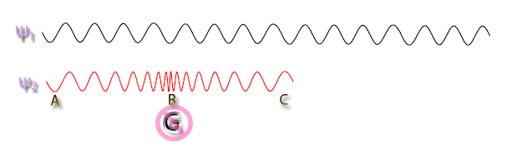
We consider two rays of light with the same phase, energy, wave length and frequency, which one of them passes by B and the other is far away and parallel of each other. Since the space is contracted, by passing the second light ray of the side of B, gradually, the length of light wave is decreasing while the frequency and energy are increasing, that is, moving to blue spectrum. But, when the second light ray gets away of B, gradually, the length of light wave is increasing and the frequency and energy are decreasing, that is, moving to red spectrum. It is clear that, in this situation the first light ray is overtaking of the second one while, the energy is fixed at all (the numbers of cycles are equal). In drawing the figure, we didn’t show the effective cases of light deviation.
As we know that, the wave length and frequency equation is:
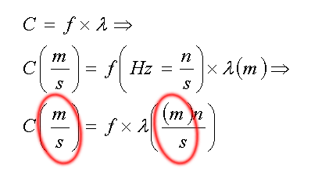
c is the fixed speed of light and his unit is meter in second, f is frequency and his unit is Hz (cycles per second), λ is wave length and his unit is meter. It’s clear that the space-time continuum is the result of dividing meter to second which is distinct at two parties of the equation. What does it mean?
If we suppose that an observer comes near B, along with the second light ray, by decreasing wave length of light his unit of length (meter), will decrease and his tool of time (chronometer or watch) will works too slow, then he never understand decreasing the speed of light and increasing the frequency and energy of electromagnetic wave. In fact, all changes at speed, frequency and energy for observers who far away from B, will be sensible and it is unnoticeable for observer who stands at B.
All three observers at A,B,C are in agreement about the speed, frequency, wave length and energy, but the fourth observer who is far away of B will find out the changes in space-time continuum, light velocity, frequency, wave length and energy.
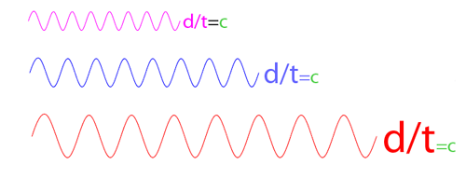
d is the length. To find the light speed, we should divide value of light displacement to value of the time changes. Since in space contract, our tool for measuring the length is decreased and our watch works slowly, we’ll get the former result for light speed and it will happen for expansion of the space-time, that is, our unit of length (meter) is longer and our watch works quickly. Pay attention to this relation:
By increasing the wave length (λ) to reason of becoming lengthen m (space expansion), the light speed should be increase with regard to the next observer’s sight but by increasing this wave length because of space-time expansion, time will be quickly, then the value of s (time) is increased and finally light speed will measure steady. But the far observer will realize the growth of light speed, because there is no change at his s (time) and m (meter) thus for near observer we can omit m/s (space-time continuum) at two parties of the contract and achieve this relation:
$$\text{300},\text{000}k=n×z$$
K is kilo = 1000, n is cycle (a light wave) and z is rate. Indeed in this situation the space-time expansion or contraction will be fixed value for speed, frequency and wave length of light to the next observer of the second light ray, all the time. And these values will be change for the far observer and it is for differences at their time and space.
The big bang theorists believe there was no space-time before the big bang and everything has been in a very hot and dense globe and after this explosion, space-time, material and energy are appeared and our space-time is expanding and is caused to increase the first wave length of explosion's light and change into the universe background waves; and they consider it, as an evidence to confirm their hypothesis. It should mention that we are the attendant light of the big bang and by space-time expansion, our unit to measure the length (meter) will become longer and also our watch (time) will works quickly. In this relation because the light speed is fixed then the frequency, wave length and energy is also fixed because our meter and time measuring tools is a subset of the world's space-time continuum. That is, we aren't observer the light of the big bang because nature of these universe background waves is radio and microwave. Thus universe background waves are not the evidence to prove the big bang theory and they are not related to the light of big bang, secondly the big bang or space-time expansion aren't cause of developing the world because in this case our meter will become longer continually and we cannot realize the universe developing because the outcome of dividing the universe diameter changing to the our meter changing will be fixed because both of them will be expand together. That is:
$$\frac{ΔU}{Δm}=\text{Cons}\text{tan}t$$
∆U is the change of universe diameter, ∆m is the change of our meter and Constant is a fixed number, and we’ll obtain the former result at anytime, but it’s not true!
Every time, we can find out developing of the universe (the galaxies are moving away of each other) with acceleration. It means that, the average size of our meter at the world is fixed. In other words:
$$\begin{aligned}\frac{ΔU}{Δm}≠\text{Cons}\text{tan}t \\ \frac{ΔU}{m}→+∞\end{aligned}$$
The result of universe diameter changing to our fixed meter is increasing day by day and this process is progressive. Indeed, the cause of developing the world is the negative gravitational field of universe that causes the galaxies move away of each other with all speed and this matter is not related into the galaxies, that is, the average size of galaxies will be fixed at all.

