The increase in speed and increasing the acceleration of reactor power of the spacecraft is
Mohammadreza Tabatabaei
contact@ki2100.net
One of the most controversial discussions in the theory of relativity to reach the speed of light is because according to the below equations and chart:
$$m_{\text{sh}}=\frac{m_{0\text{sh}}}{\sqrt{1−\frac{v^{2}}{c^{2}}}}$$
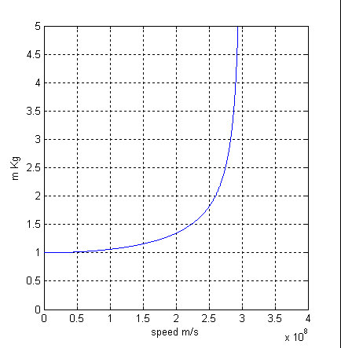

msh is mass of spacecraft on the move, mosh is mass of static spacecraft, v is speed of spacecraft and c is speed of light. Above chart is drawn for a kilogram mass of the spacecraft. As it is clear is that with the increase in speed, mass of spacecraft increase, because:
$$\begin{aligned}F=\text{ma} \\ F_{0a}=m_{0\text{sh}}a \\ F_{a}=m_{\text{sh}}a=\frac{m_{0\text{sh}}a}{\sqrt{1−\frac{v^{2}}{c^{2}}}}\end{aligned}$$
F is force, m is mass, a is acceleration, Foa is preliminary force to accelerate static spacecraft, a is considering accelerate, and Fa is necessary force to accelerate on move spacecraft that in below chart seemed 10 meter per squared second for a kilogram of mass of the spacecraft.
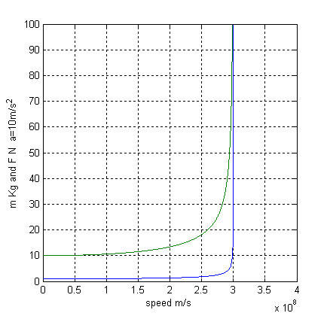
Down curve as the increase in mass with the increase speed and up curve to increase the necessary force to accelerate 10 meters per squared second compared to the increase in mass of a kilogram of ship. Surely, with increasing speed, the increase in mass also will create, and to accelerate and add to speed of spacecraft always need more power that will be extreme in speed of light, as the mass of spacecraft will be extreme in speed of light. Despite this general conclusion from these equations, some people believe that the closing to speed of light is also impossible, because a reactor’s energy cannot provide too much power supply and production and restrictions that relativity founded the speed of light and even close to it for humanity into a dream and goal impossible, let alone be more speed of light. The key to opening the door locks and breaking the limits near the speed of light is suppose spacecraft for energy supply and the need to rush to a nuclear power reactor that ripped or reactor fuel for use as usual a radioactive element or gas and hydrogen. . . And with the increase in mass and speed of ship, reactor fuel mass will increase too, and with the increase in mass of fuel, power and energy of reactor of the ship can also increase. Now by checking physical equations in this regard, we check supply power and energy to accelerate ship.
$$\begin{aligned}E={\text{mc}}^{2} \\ E_{0R}=m_{0F}×c^{2} \\ E_{R}=\frac{m_{0F}×c^{2}}{\sqrt{1−\frac{v^{2}}{c^{2}}}}\end{aligned}$$
E is energy, E0R is reactor energy in the static status of ship, m0F is mass of reactor fuel in static status, and ER is reactor energy on move status.
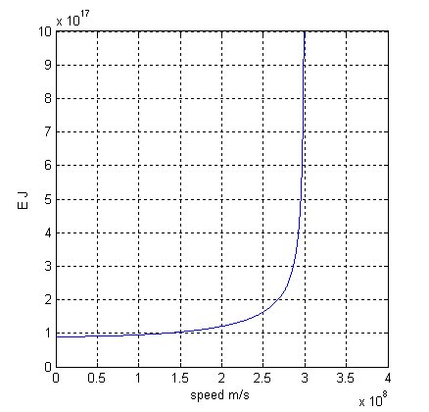
Above chart is for energy of a kilogram fuel of the nuclear reactor in the accelerating ship. As it is clear, energy of accelerating reactor also will be as much as infinite near the speed of light and provide energy and power to achieve the speed of light. But what is very important is checking necessary power to accelerate ship in the speed of light and comparison with the power of accelerating reactor to ship in the limit of light speed.

$$\begin{aligned}E=W=F×d \\ P=Wt=Et \\ P_{0a}=\frac{F_{0a}×d}{t} \\ d=\frac{d'}{\sqrt{1−\frac{v^{2}}{c^{2}}}}⇒d'=d\sqrt{1−\frac{v^{2}}{c^{2}}} \\ t=\frac{t'}{\sqrt{1−\frac{v^{2}}{c^{2}}}}⇒t'=t\sqrt{1−\frac{v^{2}}{c^{2}}} \\ P_{a}=\frac{F_{a}×d'}{t'}=\frac{\frac{m_{0\text{sh}}a}{\sqrt{1−\frac{v^{2}}{c^{2}}}}×d\sqrt{1−\frac{v^{2}}{c^{2}}}}{t\sqrt{1−\frac{v^{2}}{c^{2}}}}=\frac{m_{0\text{sh}}×a×d}{t\sqrt{1−\frac{v^{2}}{c^{2}}}}\end{aligned}$$

W is work, d is distance, P is power, t is time, P0a is preliminary power to accelerate static ship, d' is reduced length or distance, t' slowed time, Pa is necessary power to accelerate on move ship.
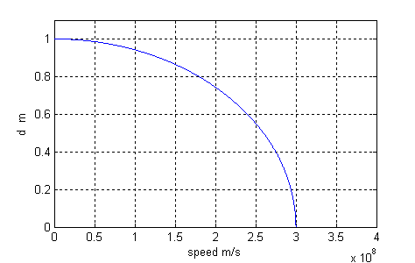
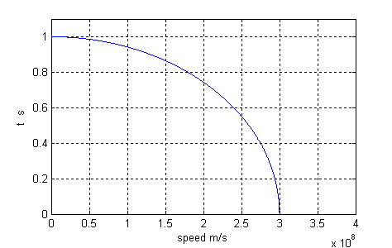

As above diagrams shows by reaching the speed of light, stopped time and three dimensions become also zero. This means that density will be extreme too, because:
$$\begin{aligned}ρ=\frac{m}{d^{3}} \\ ρ_{0}=\frac{m_{0}}{d^{3}} \\ ρ_{a}=\frac{m_{a}}{d'^{3}}=\frac{\frac{m_{0}}{\sqrt{1−\frac{v^{2}}{c^{2}}}}}{{\left(d\sqrt{1−\frac{v^{2}}{c^{2}}}\right)}^{3}}=\frac{m_{0}}{d^{3}{\left(1−\frac{v^{2}}{c^{2}}\right)}^{2}}\end{aligned}$$

ρ is density, ρ0 is density of static object, ρa is density of on move object, and ma is mass of on move object.
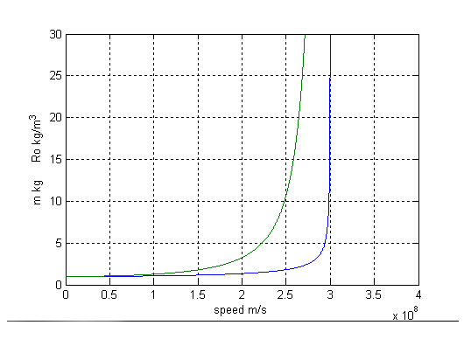
Down curve shows increase in mass, but up curve shows increase of density related to speed increasing that its increasing rate is more than mass increase.

Therefore concluded and predicted that at this critical situation all constituent particles of mass of the ship with close to each other in the end shall merge and after explosion, all mass of ship change into the energy and will be free. With regard to the above matters we can reach to a general conclusion that the world that we have two main dimensions:

- First dimension is space metric that power 3 and constitute volume. These dimensions are twitched and trigged with together.
- Second dimension is the time that related to metric dimension will be slow or fast.

Actually four dimensions space-time in relativity theory is a two dimensions length – time that change as much as their proportion and the factor of this proportion is as below:
$$\frac{1}{\sqrt{1−\frac{v^{2}}{c^{2}}}}\text{OR}\sqrt{1−\frac{v^{2}}{c^{2}}}$$
Conclusion is consonant measurement of light speed in all conditions. For example:
$$\frac{x}{t}=\frac{\frac{x'}{\sqrt{1−\frac{v^{2}}{c^{2}}}}}{\frac{t'}{\sqrt{1−\frac{v^{2}}{c^{2}}}}}=\frac{x'}{t'}=\text{Cons}\text{tan}t$$
But to reach to speed of light by spaceship, two main problems occurred:

- Whether the ship can reach the speed of light?
- If the ship can reach speed of light, its mass will be infinity and surely its free energy caused by its explosion will be infinity. Whether is possible to damage all of universe or some part of it by this way? And whether is this logic to destroy universe or its main part by using of little mass as ship mass and mass of fuel of the accelerating reactor? Whether to break the thermodynamic rules?

About first problem, we draw chart of necessary power for accelerate ship to reach light speed:

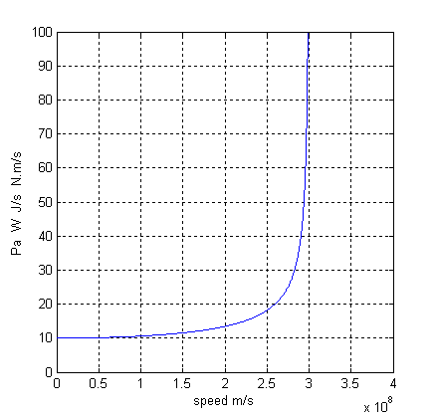

In mentioned diagram, 10 meters per squared second for each kilogram of ship mass is considered. The rate of increasing of this power is like mass increase. Now the equation for power of accelerating reactor relation to speed increase will be as below:
$$\begin{aligned}P_{0R}=\frac{E_{0R}}{t}=\frac{m_{0F}×c^{2}}{t} \\ P_{R}=\frac{E_{R}}{t'}=\frac{\frac{m_{0F}×c^{2}}{\sqrt{1−\frac{v^{2}}{c^{2}}}}}{t\sqrt{1−\frac{v^{2}}{c^{2}}}}=\frac{m_{0F}×c^{2}}{t\left(1−\frac{v^{2}}{c^{2}}\right)} \\ \end{aligned}$$
P0R is power of reactor in static status, and PR is power of reactor in the movement status.
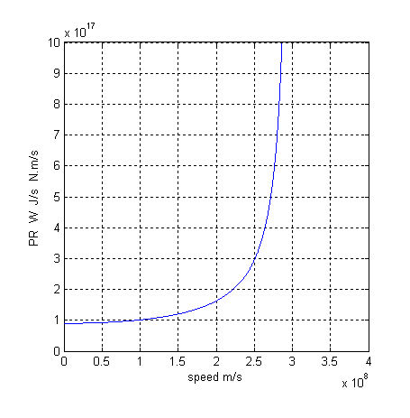
The above diagram is drawn for gotten power from one kilogram of fuel mass of the on move ship. Now by comparing these two equations, necessary power to accelerate on move ship and reactor power of on move ship is:
$$\begin{aligned}\left\{1−\frac{v^{2}}{c^{2}}≠0 | \right.\left\{v≠c | \right.\left\{c>v>0 | \right.\end{aligned}$$

We conclude that the rate of power increase of the ship's reactor is more than necessary power to accelerate ship. It mean below diagrams:
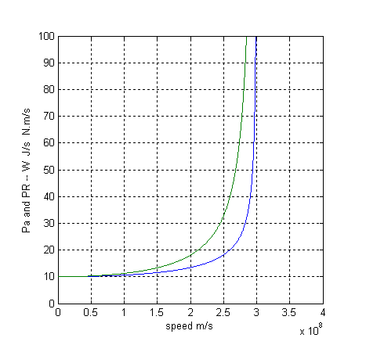
Down curve shows increase rate of power to accelerate ship and up curve is increase rate of accelerating reactor power that started from a same origin in order to compare. It means not only ship's reactor is able to reach light speed, but also can reach by increasing accelerate and in this way has extra and over power and energy,
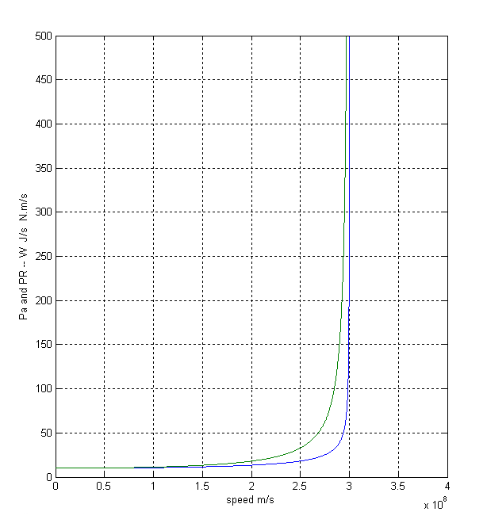

But the second problem is abstract view to physic facts!

All laws and relations of human beings in the limits in his own has been dominant and efficiency and maybe the slowing time, shorting meter, the increase in mass and … to some extent be continued and after that, these changes will be stopped and no other explosive will occur, new and different laws and relations replaced and, finally reaching the speed of light and even most of it is possible, because we will have no shortage in power and energy of accelerating reactor of the spacecraft.

Hoping for a day that design and build such spacecraft and human reach their old desire, travel in the depths of universe by maximum speed and release from all limitations and bounds. Anyway closing and reaching light speed shall examine that reactors produced energy and pioneer power will provide facilities for examination. Because by increasing mass and density, will result in increasing strength and resistance of reactor and ship.

