The calculation of filamentary photon force and its momentum transition period
Mohammadreza Tabatabaei
contact@ki2100.net
The method of calculating and the amount of corpuscular photon force have been presented in conformity with the below document, by the American Physics Society:

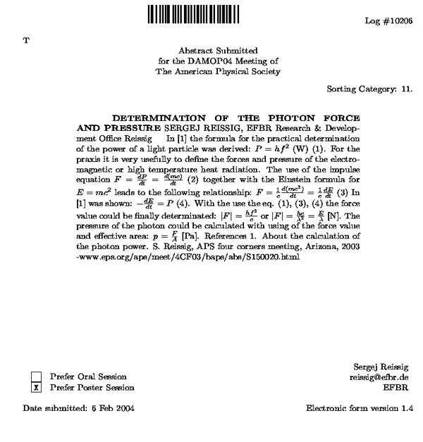

Source: http://flux.aps.org/meetings/YR04/DAMOP04/baps/abs/G120102.html
Now, our suggested method for the calculation of filamentary photon force and finding its relation with the electromagnetic wave frequency, as follows:

As we know, Energy is equal to the Force multiplied by the Distance, it means:
$$E=F×d$$
E denotes Energy, F is Force and Distance is referred to by d. As we know, total energy of photon or electromagnetic wave quantum is achieved through the Planck's known relation formula, means:
$$E_{p}=\text{hf}$$
Ep is the photon energy, h is Planck's Constants, and f is the electromagnetic wave frequency. Look at the following figure:
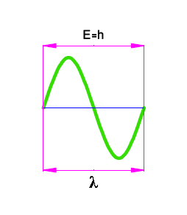
The layout of equations to calculate filamentary photon force could be seen in the first step as:

$$\begin{aligned}E=F×d \\ E_{λ}=h \\ d=λ \\ h=F_{p}×λ \\ F_{p}=\frac{h}{λ} \\ P_{p}=\frac{h}{λ} \\ F_{p}≠P_{p}⇒F_{p}≠\frac{h}{λ}\end{aligned}$$
Eλ is the energy for each cycle equal to h (Planck's Constants), λ is the wavelength, Fp is the filamentary photon force and Pp is the photon's momentum. As it was told in the chapter Particle or stringy photon, one or few-seconds photon, energy packaging in space-time, photon is a quantum filament with the number of f times λ wavelength which can transmit or induce its momentum or total energy to obstacle or balance level entirely and in a lump. So, the equations will be propounded exactly as follows:
$$\begin{aligned}E=F×d \\ E_{p}=\text{hf} \\ d=λ \\ \text{hf}=F_{p}×λ \\ F_{p}=\frac{\text{hf}}{λ} \\ P_{p}=\frac{h}{λ} \\ F_{p}=\frac{h}{λ}f=P_{p}f \\ P_{p}=\frac{\text{hf}}{c} \\ F_{p}=\frac{\text{hf}}{c}f=\frac{{\text{hf}}^{2}}{c}\end{aligned}$$
And this is just the same as - but in a new method - previously achieved result, presented by the American Physics Society, which proves more clear and simple that photon or electromagnetic energy quantum is a filament of the wavelengths equal to the wave frequency, like the same matters told in the chapter Particle or stringy photon, one or few-seconds photon, energy packaging in space-time, and the important point that photon is not carrying the forces in electromagnetic field, but is the holder of the force and oscillation energy in an alternative variant electromagnetic field. Since, a static field with no oscillation will have no radiation like waves or photons, and concerning the equations for mass, energy, momentum and photon force while the electromagnetic wave frequency is zero, all the physical components of photon will be zero and simply, there will be no quantum. We can reach the following general conclusion for the filamentary photon force:
$$\begin{aligned}F_{p}=P_{p}f=\frac{\text{hf}}{λ}=\frac{{\text{hf}}^{2}}{c}=\frac{E_{p}}{λ}=\frac{m_{p}c^{2}}{λ}=\frac{\text{hc}}{λ^{2}} \\ \frac{\text{hf}}{λ}=\frac{h\frac{c}{λ}}{λ}=\frac{\text{hc}}{λ^{2}}\end{aligned}$$
c is the velocity of light and mp is the photon's mass. The reason for the excessive photon force is that filamentary photon is able to transmit or induce its momentum or energy to the obstacle or balance level, in a very short time. This time duration, is equal to the required time for oscillating an electromagnetic wave cycle. Means:
$$Δt=\frac{1}{f}\left(\text{sec}\text{ond}\right)$$
Δt is the time to transmit filamentary photon momentum. Since, the relation between force and momentum is:
$F=\frac{ΔP}{Δt}$
ΔP is the amount of transmitted momentum. The relation between the force and filamentary photon momentum will be:
$$F_{p}=\frac{{ΔP}_{p}}{Δt}=\frac{{ΔP}_{p}}{\frac{1}{f}}={ΔP}_{p}×f$$
ΔPp is the amount of transmitted photon's momentum and if all the momentum for the filamentary photon transmitted, we'll surely reach the same results as previous:
$$F_{p}=P_{p}×f$$
In fact, the force of filamentary photon has direct relations with square root of electromagnetic wave frequency.

The diagram of frequency and filamentary photon energy
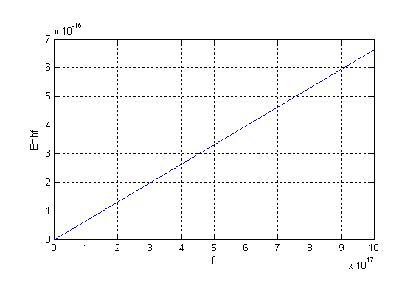

The diagram of frequency and filamentary photon momentum
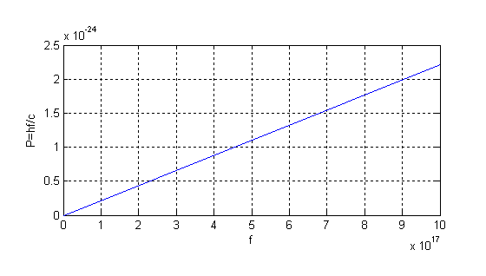
The diagram of frequency and filamentary photon force
