The big bang theory is impossible
Mohammadreza Tabatabaei
contact@ki2100.net

First we shall know what is the escape velocity?
If we shoot a bullet with a velocity lower than escape velocity (primal velocity) from surface of the earth to sky (ignoring air resistance force), the bullet will back to surround of the earth. In fact, when we shoot the bullet upside, the bullet will climb to a certain height, and then its velocity reach zero and then back to surround of the earth. In peak point, the bullet has just potential energy. The more primal velocity, the bullet more climbs. By this discussion, it is possible to define escape velocity:

Escape velocity = the minimum of the necessary velocity not to back the bullet to surround of the earth.

As the bullet not to back to the surround of the earth, so it will continue to the extreme and as it is necessary of the minimum velocity, so it will stop in the extreme. Using the gravity potential energy and kinetic energy of object, it is possible to express a formula for escape velocity. If consider gravity potential energy for a system in the extreme distance as zero, it will easy to prove that:
$$U=\frac{\text{GMm}}{r}$$
In this equation, U is gravity potential energy, M is mass for example earth mass, m is bullet's mass, G is gravity global constant, and r is the distance from the core of the earth to core of the bullet. Considering to mentioned discussion, it is possible to say:
$$\begin{aligned}U=K \\ K=\frac{1}{2}{\text{mv}}^{2} \\ \frac{\text{GMm}}{r}=\frac{{\text{mv}}^{2}}{2}⇒{\text{mv}}^{2}r=2\text{GMm} \\ v^{2}r=2\text{GM}⇒v^{2}=\frac{2\text{GM}}{r} \\ v_{\text{esc}}=\sqrt{\frac{2\text{GM}}{r}}\end{aligned}$$
K is bullet's kinetic energy, vesc is escape velocity. Recent equation is escape velocity for the bullet and as seen, it is not depend on the bullet mass. Also it is clear that if the distance between two objects tend zero, the escape velocity will tend the extreme.

Considering the mass and radius, the escape velocity for some celestial masses are as below:
The escape velocity from the sun’s surround is 617.5 kilometers per second, the MERCURY is 4.4kps, the VENUS is 10.4kps, the EARTH is 11.2kps, the moon 2.4kps and the MARS is 5kps.

The theorists of the big bang claim that all the current mass or material and energy of universe were in a very hot and dense sphere in billions years ago, and after its explosion, its energy and material dispersed and the universe created. Now want to check if this theory was correct?
$$\begin{aligned}V_{\text{esc}}=\text{Lim}\sqrt{\frac{2\text{GM}}{R}}\text{=+}∞ \\ \begin{aligned}\left\{M→+∞ | \right.\end{aligned} \\ \end{aligned}$$
For this we shall calculate escape velocity for mass and energy of the dense sphere (in first of explosion and moments after universe or space-time creation).
The escape velocity or space-time expansion is equal to limit of escape velocity general equation, when its mass tend the extreme and its radius tend zero. Because the universe mass was unbelievable and the extreme, and also sphere's radius is about zero as its unbelievable gravity pressure (it means about radius of an atomic particle). The general amount of this limit is the extreme, so it is easy to conclude that nothing (material, mass or energy) could not exit or escape from the sphere. Anyway the final velocity limit is expressed in relativity theory of light velocity and of course the light velocity is negligible compared this extra and unbelievable velocity. So it is possible to conclude that the mentioned sphere (if really existed) was a closed space that could not exit or escape from it. So if the sphere with such specifications was formed in universe because of all masses and energies aggregation, the material and energy would have to be in inelegant status and no factors would be possible to re-extract the material and energy from the sphere and make similar universe as our universe. So the Big Bang theory which is our universe existence cause and its expansion is impossible. Simply, as we knew, the light can not exit and escape from black hole (lower than Schwartz shield radius). Now this question is asked that how the light created by the Big Bang escaped from unbelievable gravity field and after chilled, converted to universe background waves?
The light does not basically chill, but the intensity of dispersed spectrum of the hot objects move to red spectrum in chilling time. Final limit for velocity is in relativity theory in light velocity that is not sufficient for the Big Bang theory. The Big Bang theory to vindicate universe needs extreme velocity which breach the relativity.

Now we have two options:
- The accuracy of the relativity theory.
- The accuracy of the Big Bang theory.

You are free to decide. But now it seems to select the accuracy of the relativity theory and reject the Big Bang theory!
Now we consider the issue from the standpoint of Finite but Boundless Universe:
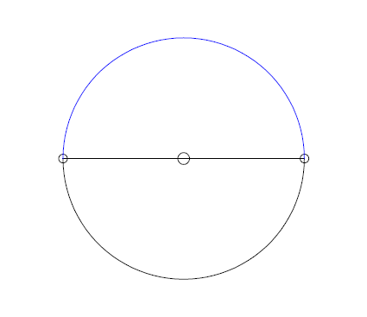
Here r is the radius of the universe. In this case, the distance between two mass, that is r, equals πr (the blue arc), because the circumference of this circle is 2πr and we should replace r with πr in the above equation. Since π possesses a fixed amount, then we will reach to the previous result. It should be explained that the universe is expanding on the surface of hypothetical sphere in this standpoint (an inflating balloon).

