Slowing time and shortening meter in gravity field, transfer to gravity blue or red
Mohammadreza Tabatabaei
contact@ki2100.net

As we know, escape velocity from the surround of the celestial mass is calculated from below equation:
$$v=\sqrt{\frac{2\text{GM}}{r}}$$
V is escape velocity of bullet, M is mass of celestial substance, G is global consonant for gravity, and r is distance from core of heavy substance to core of bullet. Now if suppose escape velocity as same as light velocity, the Schwartz Shield radius will be attained. It means that in lesser than this distance from core of celestial mass, as black hole, the light is not possible to escape and exit and will be absorbed finally by black hole. It would be same vice versa, It means if a substance downfall towards a black hole, it may seem the downfall velocity of substance will close to light velocity in this radius or distance from core of black hole (Schwartz shield radius) and in this situation, the time will stop approximately and the length will be zero approximately and this location is called zero point of space – time idiomatically. This special location can be a suitable origin for calculating and measuring gravity effects on time and meter (space - time). For this, we put escape velocity of bullet instead of substance velocity in below equations which regard to changes in time and meter submitted by Lorentz – Gerald:
$$\begin{aligned}t'=t\sqrt{1−\frac{v^{2}}{c^{2}}} \\ v=\sqrt{\frac{2\text{GM}}{r}} \\ t'=t\sqrt{1−\frac{{\left(\sqrt{\frac{2\text{GM}}{r}}\right)}^{2}}{c^{2}}}=t\sqrt{1−\frac{\frac{2\text{GM}}{r}}{c^{2}}} \\ t'=t\sqrt{1−\frac{2\text{GM}}{{\text{rc}}^{2}}} \\ d'=d\sqrt{1−\frac{2\text{GM}}{{\text{rc}}^{2}}}\end{aligned}$$
t is time, t' is slowed time, c is light velocity, d is distance, and d' is shortened distance. Two above attained equations are used to attain changes in time and distance in a gravity filed. So we have according the definition:
$$1≥\frac{2\text{GM}}{{\text{rc}}^{2}}≥0$$

The chart for increasing intensive in gravity filed and slowing time and shortening meter
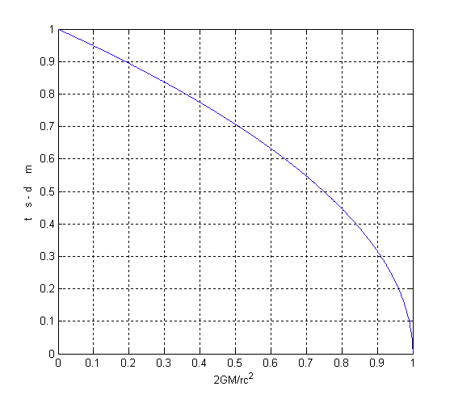
Considering that velocity and movement of light depends on space – time environment (circumference) and always measure consonant under each situation, the light wavelength shall shorten towards meter shortening, it means:
$$λ'=λ\sqrt{1−\frac{2\text{GM}}{{\text{rc}}^{2}}}$$
The above equation is loyal when the light downfall into gravity filed, but at the time of light escape from gravity filed, the below equation is confirmed:
$$λ'=\frac{λ}{\sqrt{1−\frac{2\text{GM}}{{\text{rc}}^{2}}}}$$
It means the opposite situation of the previous situation. λ is wavelength and λ’ is shortened or heightened wavelength.

The chart for downfall or light escape and its wavelength’ change (transfer to blue or transfer to gravity red)
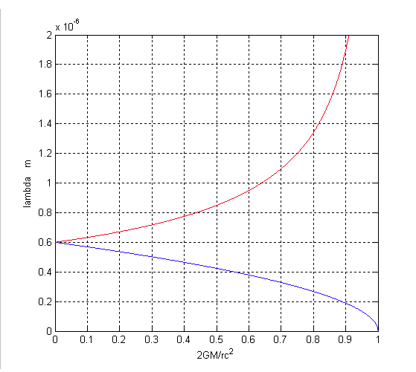

Considering that the below equations appointed in every situation:
$$\begin{aligned}fλ=c⇒λ=\frac{c}{f} \\ f'λ'=c⇒λ'=\frac{c}{f'}\end{aligned}$$
f is frequency and f’ is changed frequency, so it results:
$$\begin{aligned}λ'=λ\sqrt{1−\frac{2\text{GM}}{{\text{rc}}^{2}}} \\ \frac{c}{f'}=\frac{c}{f}\sqrt{1−\frac{2\text{GM}}{{\text{rc}}^{2}}} \\ \frac{1}{f'}=\frac{\sqrt{1−\frac{2\text{GM}}{{\text{rc}}^{2}}}}{f} \\ f=f'\sqrt{1−\frac{2\text{GM}}{{\text{rc}}^{2}}} \\ f'=\frac{f}{\sqrt{1−\frac{2\text{GM}}{{\text{rc}}^{2}}}}\end{aligned}$$
The above equation is loyal when the light downfall into gravity filed, but at the time of light escape from gravity filed, the below equation is correct:
$$f'=f\sqrt{1−\frac{2\text{GM}}{{\text{rc}}^{2}}}$$
It means the opposite situation of the previous situation. These, both, are events which is called transfer to gravity red or transfer to gravity blue.

The chart for downfall or light escape and its’ frequency changes (transfer to blue or transfer to gravity red)
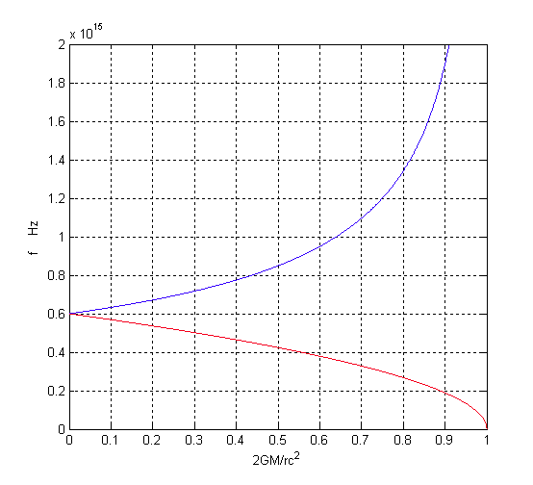
$$\begin{aligned}\frac{2\text{GM}}{{\text{rc}}^{2}}=1⇒{\text{rc}}^{2}=2\text{GM} \\ r=\frac{2\text{GM}}{c^{2}}=\frac{2×6\text{.}\text{672}×{\text{10}}^{−\text{11}}}{{\left(3×{\text{10}}^{8}\right)}^{2}}M \\ r=1\text{.}\text{48}×{\text{10}}^{−\text{27}}M\left(\text{meter}\right)\end{aligned}$$
In fact, the escape velocity is the light velocity at this location that the Schwartz Shield equation will be attained. It means in this location the wavelength tends towards zero and the frequency of the wave tends to the extreme; and also time and meter (space - time) tend towards zero.

It is interesting to know that the relativity theory suggests the same equations in regard to time slowing and meter shortening which submitted in this discussion. But about frequency changes, the below equation is suggested:
$$f'=f\left(1±\frac{\text{GM}}{{\text{rc}}^{2}}\right)$$

Now draw the chart for the above equation:
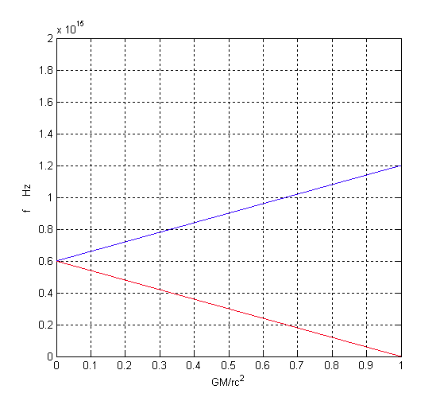
The legislated equation in general relativity and quantum mechanic has two serious problems and objections:
- The chart is linear instead of being curve.
- The equation in light escape from Schwartz shield radius (using negative mark) seems correct, because the light frequency has become zero and the light is stopped from movement. But in light downfall into gravity field (using positive mark), the light frequency is double finally and is not possible to be more which is inconsiderable and little amount that the light energy and frequency is more than these amounts at the time of light downfall into a black hole and can not be calculated by this formula.

Now merge, compare and check the above charts:
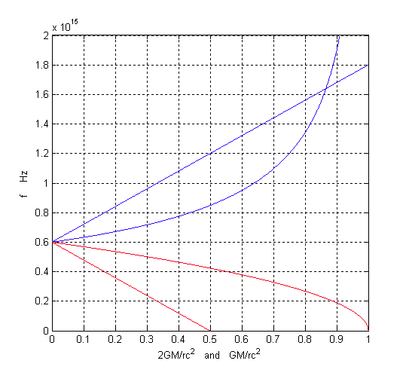
It is very clear that the attained and submitted equations in this discussion, is more correct and precious than submitted equations by Einstein general relativity or quantum mechanic. which this objection is pertinent and justified toward general relativity theory or quantum mechanic.
Now calculate the electromagnetic wave energy at the time of downfall into gravity field:
$$\begin{aligned}E=\text{hf} \\ E'=\text{hf}' \\ E'=\frac{\text{hf}}{\sqrt{1−\frac{2\text{GM}}{{\text{rc}}^{2}}}}\end{aligned}$$
E is electromagnetic shine quantum energy, E’ is secondary energy, and the h is Plank consonant. The above equation is loyal at the time of light downfall into gravity field, but the below equation is confirmed at the time of light escape from gravity field:
$$E'=\text{hf}\sqrt{1−\frac{2\text{Gm}}{{\text{rc}}^{2}}}$$
It means the opposite situation of the previous. These new equations are firstly discussed at the time of light energy or frequency transfer to gravity blue or red; and the precise tests can determine their accuracy and precision.

The chart for downfall or light escape and its energy changes (transfer to gravity blue or red)
