Particle or stringy photon, one or few-seconds photon, energy packaging in space-time
Mohammadreza Tabatabaei
contact@ki2100.net
Before beginning, it should be provided simple and brief descriptions about continuous wave and energy, and discontinuous or Quantum (packaged) wave and energy.
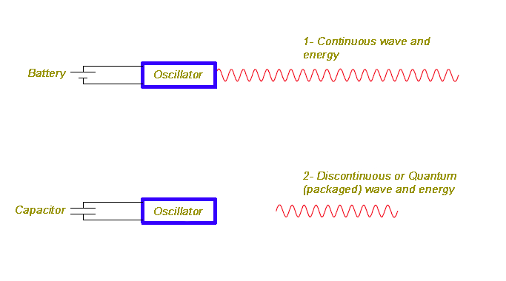
In figure 1, the battery supplies energy of oscillator runs continuously. Consequently, the oscillator will produce radio waves until finishing battery charge.

But in figure 2, the capacitor supplies energy of oscillator runs moment. Consequently, the oscillator will produce and emit radio waves discretely and cross-sectional, according to the stored energy in capacitor.

In classical physics, it can be easily produced and emitted continuous electromagnetic (radio) waves by a power supply and an oscillator circuit, but to produce light (visible spectrums) we need to stimulate orbital of atoms. For this, we can fill glass tube with pure or especial gas, (even metals steam) and we can flow a high-voltage stream, after decreasing pressure within it, which it due to charge electric field in balances of atom or encounter the stream electrons with circuit atomic electrons, which the transfer of energy is carried out in quantity of time and it will be made Quantum certainly, because of limiting balances of atoms energy in absorbing and emitting light.
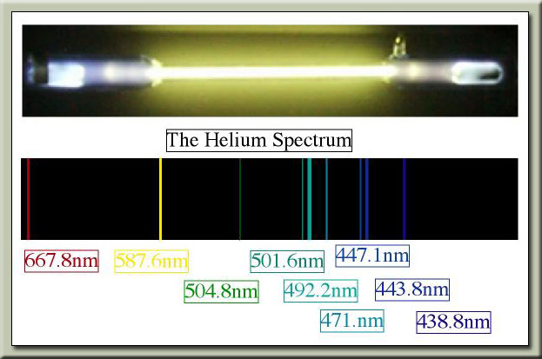
As we know, exchange of energy between atoms is Quantum or packaged which it is related to wave frequency and it is given by the famous Planck equation, i.e.:
E=hf
Where E is photon energy or discrete electromagnetic wave, f is frequency of electromagnetic wave and h is the Planck constant, which it has a micro-energy equivalent to $6\text{.}\text{626}×{\text{10}}^{−\text{34}}js$.
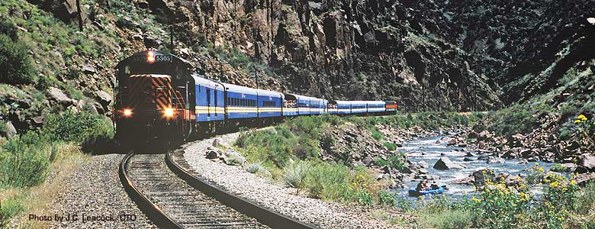
As we know, all trains have one locomotive which it provides force moving or acceleration of the whole collection (locomotive itself and wagons). Now we use the following formula to calculate momentum of train:
$$P=\text{mv}=m_{t}×v_{t}=\left(m_{v}×n\right)×v_{t}+m_{l}×v_{t}$$
Where P is momentum of the train, m is mass, v is velocity, mt is mass of train, vt is speed of train, mv is mass of every wagon, n is number of wagons and ml is mass of tracker or train's horse. Now, if an obstacle comes forward the train, all momentum or kinetic energy of the train will be transfer to the obstacle in collision moment and it isn't necessary that all wagons pass the location of the crash, because material of the train is rigid and connected together and this momentum from end wagon to front as well as tracker train is transferred to collision point and the obstacle.

If it crashes with a heavy obstacle, and momentum wants to transfer in a short time, it is natural that wagons are back slide from their route and railroad. Because wagons are connected together by drive axle and they have freedom of rotation and the force of impact will scatter them.

What Is Gamma Radiation?
Gamma ray is an electromagnetic wave, of course, with very high frequency. According to current definitions, electromagnetic wave is electrical sinus oscillation of there is appeared a similar magnetic field perpendicular to it. See the following figures:
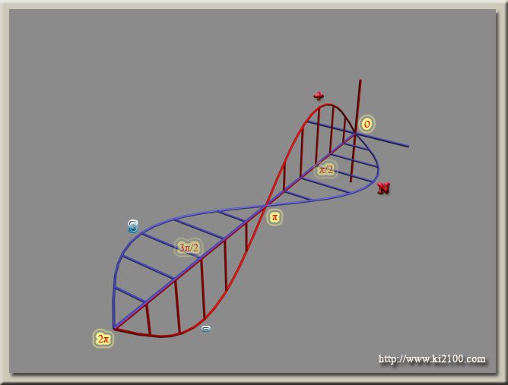

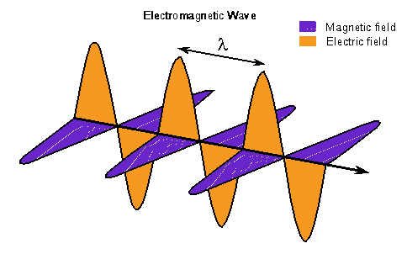
Now, we separate the two waves and survey them separately:
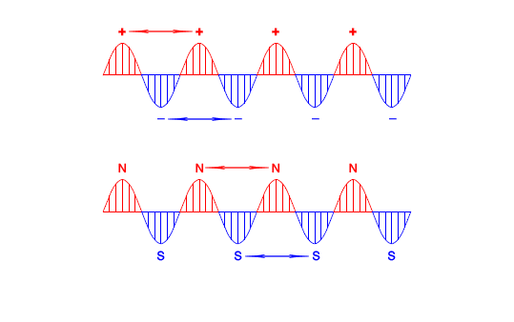
As we know, same electric and magnetic poles dispel themselves, and they have been located beside together in electromagnetic wave, so by collision with these x or γ rays, momentum and impact of the last discrete wavelength is transferred to the first wavelength as well as collision point and obstacle by buoyancy and electromagnetic assertion force of the same pole, and it isn't necessary to pass all wavelengths from point of collision and obstacle. Now, we measure momentum of electromagnetic wave quantum or so called photon:
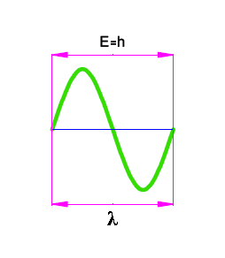
Here E is energy of every cycle of electromagnetic wave, which its value is h, the Planck constant and λ is the wavelength. We calculate momentum of each wave cycle, in the first stage.
$$\begin{aligned}E={\text{mc}}^{2}⇒m=\frac{E}{c^{2}} \\ E=h⇒m=\frac{h}{c^{2}} \\ P=\text{mv} \\ v=c⇒P=\frac{h}{c^{2}}c=\frac{h}{c} \\ c=λf⇒P=\frac{h}{λf}\end{aligned}$$
Here E is energy and m is mass in mass-energy equivalence principle and c is light speed, after calculating momentum of a wave cycle, we multiply it on the total frequency, of course in a one second period, and then we achieve total momentum of discrete electromagnetic wave:
$$\begin{aligned}P=\frac{h}{c}×f=\frac{\text{hf}}{c} \\ P=\frac{h}{λf}×f=\frac{h}{λ}\end{aligned}$$
Which the obtained result is similar previous results, i.e.:
$$P=\frac{h}{λ}=\frac{\text{hf}}{c}=\frac{E}{c}$$
And overall conclusion is that energy is quantum (packaging) in the some ranges of space-time which it is related to the time, i.e. second and distance by light during in one second which it indicates this important fact that our current traditional divisions such as second , minutes, hours and ... aren't deducted by human beings; instead they are related to high-intelligent creatures which they are using from an advanced geometry and mathematics and they have transferred knowledge of measurement of time and calendar to us and the first clock, i.e. time indicator has been made by them, because the used frequency unit in Planck equation is as cycle on second, it means that electromagnetic energy is packaging in quantity of time and its unit is second and length that its unit is meter. We can suppose this package as a mechanical mass i.e. photon or stringy with the length of $c×t$ and t=1. Electromagnetic waves show various behaviors when absorption, production and clash with the obstacle. For example, some of them are reflected by the atmosphere layers and some of them such as microwave (radar), are absorbed by water but they are reflected by the rigid bodies. Also visible spectrums are reflected by smooth surfaces such as mirror. The x-ray is reflected in Compton phenomenon, if radiation angle is perpendicular, but if it is lesser than this angle, some of its energy is absorbed by electron and the rest of wave is diverted and ...which all of them aren’t imagined by particle like of electromagnetic and light, but quantum of the light or photon isn't a particle and it is stringy with $c×t$ length, and t is one second, and wavelength λ and its number is dependent on amount of f (frequency), i.e. the following figure:
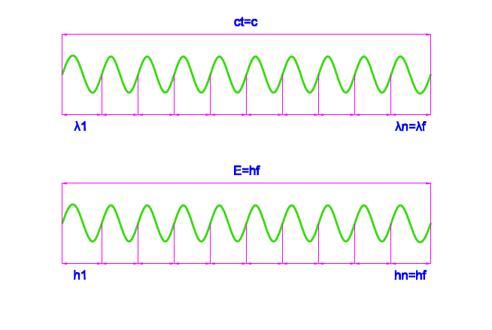
But these quanta can interact with particles without mass, and they can appear massy or pregnant particles. By these descriptions, all radiated photons by atoms are one second photons, and it will not be meant that their emission and absorption needs to one second time, but energy of electromagnetic quanta in space-time is quantum and packaged as fixed quantity c, and speed of their production and emit is very shorter than one second and it is almost instantaneous. Now, it is raised this important question whether we can connect quanta of electromagnetic energy together?
Which if we success in this matter, energy of these quanta will be calculated by the following equation:
$$E=t×\text{hf}$$
Where t is time in second unit, as which these photons are called multi-second quanta and they will have extraordinary energy and their production and emission is possible and rational, because radio waves are produced with longer length. For example, we evaluate energy of a 60 seconds (or one minute) gamma quantum (stringy photon):
$$\begin{aligned}t=\text{60} \\ h=6\text{.}\text{626}×{\text{10}}^{−\text{34}} \\ f={\text{10}}^{\text{22}} \\ E=? \\ E=\text{60}×6\text{.}\text{626}×{\text{10}}^{−\text{34}}×{\text{10}}^{\text{22}} \\ E=\text{397}\text{.}\text{56}×{\text{10}}^{−\text{12}}J \\ E=\frac{\text{397}\text{.}\text{56}×{\text{10}}^{−\text{12}}}{1\text{.}\text{602}×{\text{10}}^{−\text{19}}}=2\text{.}\text{48}×{\text{10}}^{9}=2\text{.}\text{48}\text{GeV}\end{aligned}$$
It seems that energy of this one minute gamma quantum is sufficient for fission each heavy nucleus especially metal nucleus and it can be slashed nucleus not richen and mined uranium easily and achieve to comfortable and huge energy. Although the generators of a few seconds photon can also be used in military applications, i.e. mass of object itself can provide huge nuclear energy for its explosion, by reflecting these few second quanta to the object. However this issues is related to human nature and physics science, which we can use all phenomena and science in both peace or war direction, and its expression and alarm is necessary by provider of theory, and its military application can not prevent from providing the theory itself, because its manufacturer is responsible for it's rather than theorists' phenomenon. But this must be noted that if we can produce few seconds' quanta of electromagnetic waves, we will achieve to an easier solution, in comparison with the current fission or fusion in future, because we can use metals such as tungsten and regulate the reaction speed of fission by intensity of generator of radiation laser like waves.

Perhaps this new matter seems very strange and it’s better to make it some more intelligible!
Imagine that there are intelligent creatures who live in a planet very far away from us and in their timings, every their second equals our 2 seconds. As they are thoughtful and interested in science, they know about quantum energy of electromagnetic waves in photoelectric phenomenon and they know how to calculate such energy using Planck relation. Something that is different is that their Planck constant is calculated as the half of our Planck constant, because:
$$\begin{aligned}S=2s \\ F\left(2×\text{cycles }S\right)=2f\left(\text{cycles }s\right) \\ H=\frac{1}{2}h \\ E=\text{hf}=\text{HF}=\frac{1}{2}h×2f\end{aligned}$$
For them, S as each second equals our 2 seconds, F as frequency of electromagnetic wave calculated by them, that is twice bigger than frequency of calculated by us (in the same and definite range of spectrum). And for them, H as Planck constant must equal half a Planck constant calculated by us so, by this way they and us could get the same result when calculating the quantum energy of a definite spectrum.
Such intelligent creatures surely know about the Mass-energy equivalence principle, Compton and De Broglie relations, etc. and they find below equations:
$$\begin{aligned}C=2c⇒c=\frac{C}{2} \\ E={\text{mc}}^{2}=m{\left(C2\right)}^{2} \\ P=\frac{\text{hf}}{c}=\frac{\text{HF}}{C2}=\frac{2\text{HF}}{C}=\frac{2E}{C} \\ P=\frac{h}{λ}=\frac{2H}{λ} \\ V=2v⇒v=\frac{V}{2} \\ λ=\frac{h}{P}=\frac{2H}{\text{mv}}=\frac{2H}{mV2}=\frac{4H}{\text{mV}}\end{aligned}$$
C, the constant speed of light for them, that is twice bigger than c for us (calculated by us) and V, the calculated speed for dynamic bodies by them, that is twice bigger than v calculated by us. For Compton phenomenon we have:
$$λ'−λ=\frac{h}{m_{e}c}\left(1−\text{cos}θ\right)=\frac{2H}{m_{e}C2}\left(1−\text{cos}θ\right)=\frac{4H}{m_{e}C}\left(1−\text{cos}θ\right)$$
In the above equation, me shows the rest mass of the electron, θ shows diffraction angle, λ shows wavelength of radial photon and λ' shows the wavelength of diffracted photon. Finally, these intelligent creatures find out that they have made a mistake in timing and defining a standard unit for timing and in order to remove these numeral coefficients from the above equations, they adjusted the unit for timing to our unit for timing. In other words, as such knowledge did not exist in the period of our ancestors, one could conclude that intelligent creatures lived before us and they had such experiences so, they could do timing among others they noticed seconds and at last their findings have been transferred to us.

