Increasing Velocity and Calculating Gravity Potential Energy- Investigating our Vision Depth in the Cosmos

As we know escape velocity from surface of a celestial body is given by following equation:

$$v=\sqrt{\frac{2\text{GM}}{r}}$$

v is escape velocity of the bullet, M is mass of heavy celestial body, G is constant of gravity, and r is distance of center of heavy mass from center of the bullet. In classic physics, kinetic energy of a bullet will be calculated by the following equation:

$$E=\frac{1}{2}{\text{mv}}^{2}$$

E is kinetic energy and m is bullet mass. Now, we want to calculate kinetic energy of the bullet in escape velocity:

$$\begin{aligned}E=\frac{1}{2}{\text{mv}}^{2} \\ v=\sqrt{\frac{2\text{GM}}{r}} \\ E=\frac{1}{2}m{\left(\sqrt{\frac{2\text{GM}}{r}}\right)}^{2}=\frac{1}{2}m\frac{2\text{GM}}{r}=\frac{\text{GMm}}{r} \\ \frac{\text{GMm}}{r}=U=E\end{aligned}$$

U is classic gravity potential energy. The gained result is classic gravity potential energy, because the escape velocity is given by the following equation:

$$\begin{aligned}E=U \\ \frac{1}{2}{\text{mv}}^{2}=\frac{\text{GMm}}{r}\end{aligned}$$

Now, we calculate relativity gravity potential energy of the bullet:

$$\begin{aligned}U=\text{mgh} \\ h=r \\ F=\frac{\text{GMm}}{r^{2}}=\text{mg}⇒g=\frac{\text{GM}}{r^{2}} \\ U=m\frac{\text{GM}}{r^{2}}r=\frac{\text{GMm}}{r} \\ m=\frac{m_{0}}{\sqrt{1−\frac{v^{2}}{c^{2}}}} \\ U=\frac{\text{GM}\frac{m_{0}}{\sqrt{1−\frac{v^{2}}{c^{2}}}}}{r}=\frac{{\text{GMm}}_{0}}{r\sqrt{1−\frac{v^{2}}{c^{2}}}} \\ r=\text{vt}+r_{0} \\ U=\frac{{\text{GMm}}_{0}}{\left(\text{vt}+r_{0}\right)\sqrt{1−\frac{v^{2}}{c^{2}}}}\end{aligned}$$

g is gravitational acceleration, h is height or distance of gravity field center and center of bullet, i.e. r, F is gravity force between celestial body and bullet, m0 is station mass of bullet, c is the light velocity, and r0 is primary distance of celestial body and bullet. In other hand, we have:
$$\begin{aligned}E=\frac{m_{0}v^{2}}{2\sqrt{1−\frac{v^{2}}{c^{2}}}}=\frac{m_{0}{\left(\sqrt{\frac{2\text{GM}}{r}}\right)}^{2}}{2\sqrt{1−\frac{v^{2}}{c^{2}}}}=\frac{m_{0}\frac{2\text{GM}}{r}}{2\sqrt{1−\frac{v^{2}}{c^{2}}}}=\frac{{\text{GMm}}_{0}}{r\sqrt{1−\frac{v^{2}}{c^{2}}}} \\ U=E⇒U=\frac{{\text{GMm}}_{0}}{r\sqrt{1−\frac{v^{2}}{c^{2}}}}\end{aligned}$$

Comparison Diagrams of Classic Kinetic Energy and Relative Kinetic Energy

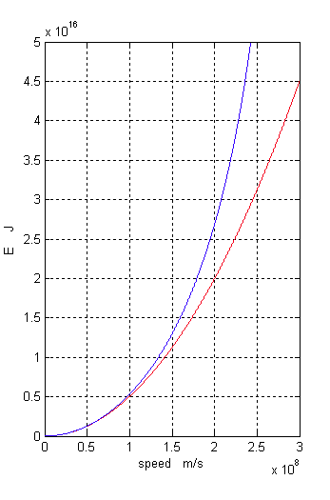

The red curve indicates increasing of classic kinetic energy and the blue curve indicates increasing of relativity kinetic energy of the bullet. In order to calculate escape velocity, by comparison relativity kinetic energy and relativity potential energy of the bullet, we have:

$$\begin{aligned}U=E \\ \frac{{\text{GMm}}_{0}}{r\sqrt{1−\frac{v^{2}}{c^{2}}}}=\frac{m_{0}v^{2}}{2\sqrt{1−\frac{v^{2}}{c^{2}}}} \\ \frac{\text{GM}}{r}=\frac{v^{2}}{2} \\ {\text{rv}}^{2}=2\text{GM} \\ v^{2}=\frac{2\text{GM}}{r} \\ v=\sqrt{\frac{2\text{GM}}{r}}\end{aligned}$$

There is gained the same previous result in classic physics. So, this equation is validated in relativity (high velocities). Now we draw and comparison diagrams of classic gravity potential energy and relativity gravity potential energy. We consider the motion as accelerated motion and its acceleration is supposed as c in square of second, i.e. by supposing a=c, we have:

$$\begin{aligned}r=d=\frac{1}{2}{\text{at}}^{2} \\ a=\frac{v}{t}⇒v=\text{at} \\ U=\frac{{\text{GMm}}_{0}}{r\sqrt{1−\frac{v^{2}}{c^{2}}}}=\frac{{\text{GMm}}_{0}}{\frac{1}{2}{\text{at}}^{2}\sqrt{1−\frac{{\left(\text{at}\right)}^{2}}{c^{2}}}} \\ U=\frac{2{\text{GMm}}_{0}}{{\text{at}}^{2}\sqrt{1−\frac{{\left(\text{at}\right)}^{2}}{c^{2}}}}\end{aligned}$$

d is covered distance, and a is acceleration.

$$\begin{aligned}U=\frac{2{\text{GMm}}_{0}}{{\text{at}}^{2}\sqrt{1−\frac{a^{2}t^{2}}{c^{2}}}}=\frac{2{\text{GMm}}_{0}}{{\text{ct}}^{2}\sqrt{1−\frac{c^{2}t^{2}}{c^{2}}}} \\ U=\frac{2{\text{GMm}}_{0}}{{\text{ct}}^{2}\sqrt{1−t^{2}}}\end{aligned}$$

By considering to this matter that the surface of above equation is always a constant numerical, in comparison with time, velocity and acceleration of bullet, by displacing ${\text{10}}^{7}$ instead GMm0, we can draw curves.

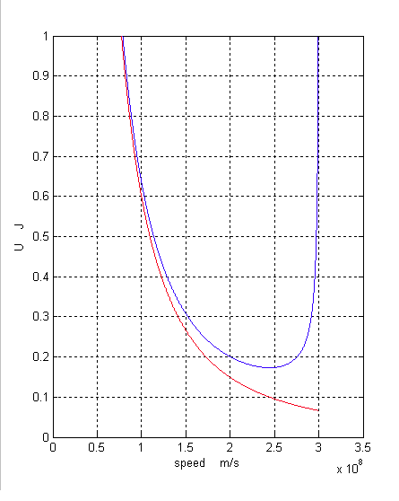

The red curve is related to classic gravity potential energy of bullet, but the blue curve indicates its relativity gravity potential energy. It is clear that relativity gravity potential energy is decreased to 250.000 Km/s, but it is increased after that. Now, we draw diagrams according to time and distance:
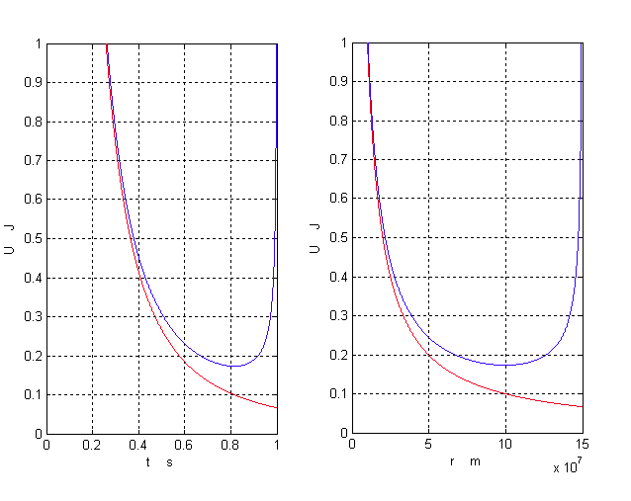

As you see in the above diagrams, diagrams of relativity gravity potential energy have a minimum quantity comparison with time, velocity, and distance. In order to find this quantity, we must calculate differential of resulted equation or function for relativity gravity potential energy according to t, and consider it as zero and then calculate t:

$$\begin{aligned}U'\left(t\right)=−\frac{4{\text{GMm}}_{0}}{{\text{ct}}^{3}\sqrt{1−t^{2}}}+\frac{2{\text{GMm}}_{0}}{\text{ct}{\left(1−t^{2}\right)}^{32}}=0 \\ t≈0\text{.}\text{816}\end{aligned}$$

This quantity has been gained for t approximately and by drawing differential diagram (the following red curve):

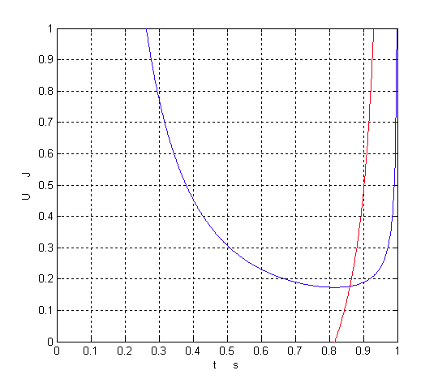

And for this velocity, we certainly have:

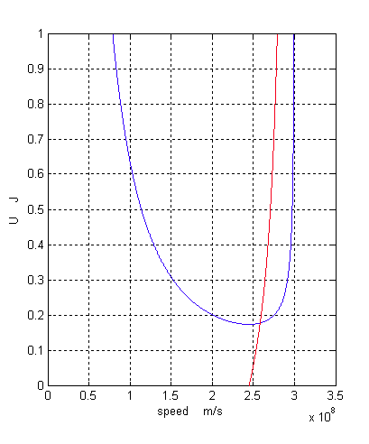

That it is gained 245,000 Km/s. By considering to these matters, we can calculate our depth vision in cosmos.

Our depth vision in cosmos:
As we said previously, Big Bang Theory is an impossible theory. Now, if we suppose that energy and particles could exit and escape from primary hot corpuscle, acceleration of the cosmos expansion could not be more than 1$cs^{2}$, and resulted equation about relativity gravity potential energy in this topic will be governed. As you can see in the above diagrams, relativity gravity potential energy of escaped masses with acceleration $cs^{2}$ in velocity 245,000 Km/s is a minimum quantity, but it will be increased after that; it seems that increasing velocity will be stopped in this point and therefore, velocity is constant and acceleration will be zero, because in order to increase velocity, we need a huge kinetic energy, which its providing source is unknown yet. As we know observations of Hobble, a physicist, showed that galaxies are being far from us by v velocity, which it is resulted by the following equation:

V=HX

H is Hobbles constant, and X is distance from the Earth. In fact, this equation can be used for any point of the universe. In briefly, velocity will be increased about 21,77 Km/s, instead of each one million light year distance from us. The farthest distance of celestial bodies from us is estimated 12 billion light years, i.e. sent ultra-depth picture by mapping camera of Hobble, NASA. Now, by considering to the above – mentioned matters, we can calculate our depth vision in cosmos. For this, we divide escape velocity 245,000 Km/s (the maximum current escape velocity in the cosmos, resulted from Big Bang theory and relativity theory) on 21,77 Km/s, which we get 11.254 billion light year, and it is supposed that there isn’t anything upper than this permitted velocity or distance! But in future, if celestial bodies will be observed beyond our current depth vision, which they have certainly more distance and velocity, Big Bang Theory will be cancelled in explanation of the cosmos extension spontaneously.

