Doppler phenomenon for electromagnetic waves and new equations for relativity quantum
Mohammadreza Tabatabaei
contact@ki2100.net

What is the Doppler effect?
Because of Doppler phenomenon importance in cosmology, it is necessary to have a short revision. Doppler phenomenon is considered in classic physic for changes in frequency of sound source. According to this effect, whenever an observer is on move compared to a sound source, he will receive another frequency which dispatched by source. For example, if an ambulance with certain speed is on move toward us, its alert sound makes change in sending waves because of sound source movement, and more closing us more acute alert (more frequency and shorter wavelength) is heard and when it passes beside us and far away, the alert becomes graver (shorter frequency and longer wavelength).

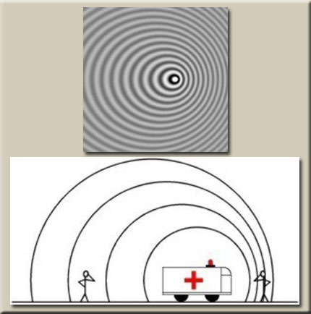

This phenomenon is called Doppler Effect which is same in light too. It means whenever light resource is on move toward observer , the frequency of receiving light will change, if observer and source may being far away, the frequency of receiving light will go toward red and if may being near, the frequency of receiving light will go toward blue. After presenting relativity theory, Doppler Effect for electromagnetic waves has discussed. In relativity Doppler Effect, because wave dispatching source shines electromagnetic waves and behavior of these category of waves described by Special relativity, therefore it differs with classic Doppler. Because according to special relativity – based on unifying physical rules in all inertia reference frames - the existence of any supreme reference frame in universe will disavow. Because of this, source moving towards observer or observer moving toward source has no difference. In this phenomenon, if source moving towards observer or observer moving toward source, there will be a displacing toward blue spectrum. It means below equation:
$$λ_{0}=\sqrt{\frac{1−vc}{1+vc}}λ_{e}$$
Which λ0 is receiving wave length, and λe is wavelength that sends by light source. It is clear that in this situation receiving wavelength is smaller than sending wavelength. If source from observer or observer from source is far away, with increasing in receiving light wavelength, there will be a displacing in absorbing or emission as below equation:
$$λ_{0}=\sqrt{\frac{1+vc}{1−vc}}λ_{e}$$
Now this subject will survey under classic mechanic, relativity and quantum mechanics:
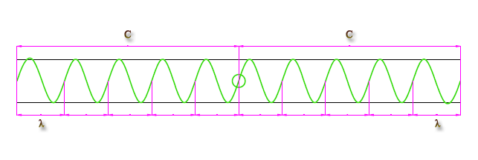
In below picture, the source of green spectrum (central circle) is spotted consonant. For its wavelength and frequency have:
$$\begin{aligned}c=λf \\ λ=\frac{c}{f} \\ f=\frac{c}{λ}\end{aligned}$$
C is light speed, λ is wavelength, and f is frequency of electromagnetic wave. Now if source of green spectrum displace with v speed, we have:
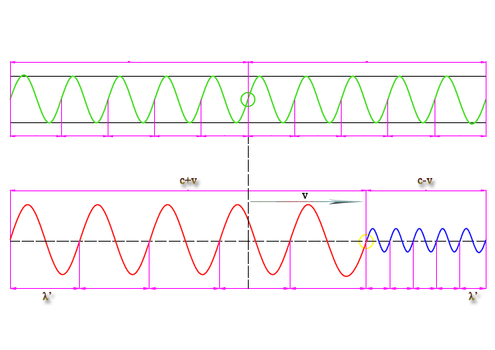
$$\begin{aligned}1) \\ λ'=\frac{c±v}{f}=\frac{c±v}{cλ}=\frac{λ\left(c±v\right)}{c} \\ λ'=\frac{\left(c±v\right)}{c}λ \\ 2) \\ λ'=\frac{c}{f'}=\frac{c±v}{f} \\ \text{fc}=f'\left(c±v\right) \\ f'=\frac{c}{\left(c±v\right)}f \\ f'=\frac{v}{\left(v±v_{s}\right)}f\end{aligned}$$
λ' is received wavelength, v is source speed, λ is source wavelength, f is source frequency and f ' is receiving frequency. In latest equation, v is speed of wave – for example sound – and Vs is wave or sound source speed. The above equations are referred to classic equations for Doppler Effect. For example a police car is dispatching alert with 4000 Hz and closing to a static passenger with 72km/hour speed and far away from another, what is the amount of sound frequency? The speed of sound in air is 340m/s:
$\begin{aligned}f=\text{4000}\text{Hz} \\ v_{s}=\text{72}{\text{km}}/h=\text{20}m/s \\ v=\text{340}m/s \\ f'=? \\ f'=\frac{\text{340}}{\text{340}±\text{20}}×\text{4000}=\frac{\text{340}}{\text{360}∧\text{320}}×\text{4000} \\ f'=\text{3777}\text{.}7∧\text{4250}\text{Hz}\end{aligned}$
But as we knew, by increasing speed of light source, the time will be slow and length will be short, so observer beside the light source won't understand difference in frequency and wavelength and also will reach to previous result in light speed measurement. But in view of other observer not with light source, the more increase in speed and slower in time and shorter in length, the more decrease in frequency of spectrum. It means moving toward yellow spectrum from green spectrum that no observer could see it, else it will be beside source of light and makes changes in measurement units of length and time. This spectrum is understood just by observation based on Gerald – Lawrence contraction. So the classic equation will change to below equation that f'' is frequency of on move source spectrum with V speed.
$$λ'=\frac{c±v}{f\text{''}}$$
As we knew the units of frequency is cycle per second and by slowing time, surely the frequency of source spectrum, will be decreased for observers that they don't beside the source. It means:
$$\begin{aligned}t=\frac{t'}{\sqrt{1−\frac{v^{2}}{c^{2}}}} \\ f=\frac{f\text{''}}{\sqrt{1−\frac{v^{2}}{c^{2}}}} \\ f\text{''}=f\sqrt{1−\frac{v^{2}}{c^{2}}} \\ λ'=\frac{c±v}{f\sqrt{1−\frac{v^{2}}{c^{2}}}} \\ f=\frac{c}{λ} \\ λ'=\frac{c±v}{\frac{c}{λ}\sqrt{1−\frac{v^{2}}{c^{2}}}}=\frac{λ\left(c±v\right)}{c\sqrt{1−\frac{v^{2}}{c^{2}}}}=\frac{c±v}{\sqrt{c^{2}−\frac{c^{2}v^{2}}{c^{2}}}}λ \\ λ'=\frac{c±v}{\sqrt{c^{2}−v^{2}}}λ\end{aligned}$$
t is time, t' is slowed time, and f" is frequency of on move source. Its ease and advantage compared old formula is that we just change a sign in numerator of the equation which simplify its learning and application.
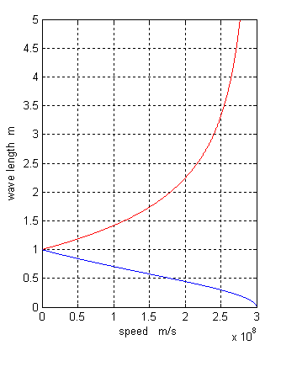
The below curve shows shortening in wavelength by increasing speed of closing source to observer (blue tendency) and upper curve shows lengthen in wavelength by increasing speed of far away source from observer (red tendency).

Now we compare result from new formulas and old formulas:

 | V=0 | V=0.25c | V=0.5c | V=0.75c
$$\sqrt{\frac{1−vc}{1+vc}}$$ | 1 | 0.7745 | 0.5773 | 0.3779
$$\frac{c−v}{\sqrt{c^{2}−v^{2}}}$$ | 1 | 0.7745 | 0.5773 | 0.3779
$$\sqrt{\frac{1+vc}{1−vc}}$$ | 1 | 1.2909 | 1.7320 | 2.6457
$$\frac{c+v}{\sqrt{c^{2}−v^{2}}}$$ | 1 | 1.2909 | 1.7320 | 2.6457

$$\begin{aligned}\sqrt{\frac{1−\frac{v}{c}}{1+\frac{v}{c}}}=\sqrt{\frac{\frac{c−v}{c}}{\frac{c+v}{c}}}=\sqrt{\frac{c−v}{c+v}}=\sqrt{\frac{\left(c−v\right)\left(c−v\right)}{\left(c+v\right)\left(c−v\right)}}=\sqrt{\frac{{\left(c−v\right)}^{2}}{c^{2}−v^{2}}}=\frac{c−v}{\sqrt{c^{2}−v^{2}}} \\ \sqrt{\frac{\left(c−v\right)\left(c+v\right)}{\left(c+v\right)\left(c+v\right)}}=\sqrt{\frac{c^{2}−v^{2}}{{\left(c+v\right)}^{2}}}=\frac{\sqrt{c^{2}−v^{2}}}{c+v} \\ ⇒\sqrt{\frac{1−\frac{v}{c}}{1+\frac{v}{c}}}=\sqrt{\frac{c−v}{c+v}}=\frac{c−v}{\sqrt{c^{2}−v^{2}}}=\frac{\sqrt{c^{2}−v^{2}}}{c+v} \\ \\ \\ \\ \sqrt{\frac{1+\frac{v}{c}}{1−\frac{v}{c}}}=\sqrt{\frac{\frac{c+v}{c}}{\frac{c−v}{c}}}=\sqrt{\frac{c+v}{c−v}}=\sqrt{\frac{\left(c+v\right)\left(c+v\right)}{\left(c−v\right)\left(c+v\right)}}=\sqrt{\frac{{\left(c+v\right)}^{2}}{c^{2}−v^{2}}}=\frac{c+v}{\sqrt{c^{2}−v^{2}}} \\ \sqrt{\frac{\left(c+v\right)\left(c−v\right)}{\left(c−v\right)\left(c−v\right)}}=\sqrt{\frac{c^{2}−v^{2}}{{\left(c−v\right)}^{2}}}=\frac{\sqrt{c^{2}−v^{2}}}{c−v} \\ ⇒\sqrt{\frac{1+\frac{v}{c}}{1−\frac{v}{c}}}=\sqrt{\frac{c+v}{c−v}}=\frac{c+v}{\sqrt{c^{2}−v^{2}}}=\frac{\sqrt{c^{2}−v^{2}}}{c−v}\end{aligned}$$
As it is clear, the results are same and now after confidence of equation accuracy, try to merge these equations with equations in quantum mechanics and catch new formulas:
$$\begin{aligned}f'=\frac{c}{λ'}=\frac{c}{\frac{c±v}{f\sqrt{1−\frac{v^{2}}{c^{2}}}}}=\frac{\text{fc}\sqrt{1−\frac{v^{2}}{c^{2}}}}{c±v}=\frac{\sqrt{c^{2}−\frac{c^{2}v^{2}}{c^{2}}}}{c±v}f \\ f'=\frac{\sqrt{c^{2}−v^{2}}}{c±v}f\end{aligned}$$
The above equation shows the frequency of received electromagnetic waves from a source which is closing or far away to observer. That f is source frequency and f' is received frequency to observer.
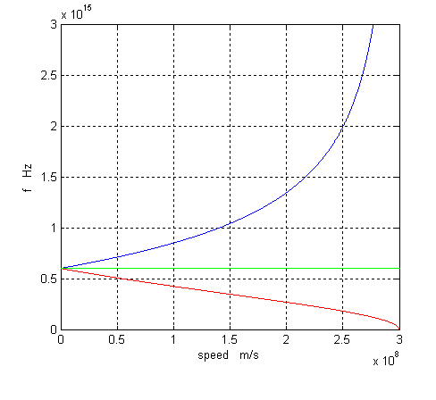
The upper curve shows frequency increase, by increasing speed of source closing to observer (blue tendency) and the below curve shows frequency decrease, by increasing speed of source far away observer (red tendency).
$$\begin{aligned}E=\text{hf}\text{''} \\ f\text{''}=f\sqrt{1−\frac{v^{2}}{c^{2}}} \\ E=\text{hf}\sqrt{1−\frac{v^{2}}{c^{2}}} \\ \text{Lim}\left(\text{hf}\sqrt{1−\frac{v^{2}}{c^{2}}}\right)=0 \\ v→c\end{aligned}$$
E is photon energy and h is Plank consonant. The above equation and limit shows energy of electromagnetic wave of the on move source. As it is clear by closing to light speed, the energy of radiant wave is decreased by source that this will cause balance in source and prevent explosion and mass convert to energy. In fact by closing to light speed, the temperature will close to absolute zero which will discussed in next discussions.
$$\begin{aligned}E=\text{hf}' \\ f'=\frac{\sqrt{c^{2}−v^{2}}}{c±v}f \\ E=\text{hf}\frac{\sqrt{c^{2}−v^{2}}}{c±v}\end{aligned}$$
And this is the general and final equation to achieve energy of electromagnetic waves received from on move source. The general conclusion is that energy in some ranges of space – time is quantized that referred to second and paced distance by light in a second. Which express this fact that common time division as second, minute, hour and … was not done by human, but done by super intelligent life who use professional geometry and mathematics as dozen calculation and they transferred us these time and calendar knowledge and first watch, means time showing was made by them. Because the unit of frequency in Plank formula is cycle per second, and this means electromagnetic energy is quantized and packaged in time and unit of it is second and also length with meter unit. We can consider this package as mechanical bit like photon or a string of c.t length and t=1 which will be discussed after.

