

محافظ اهمی، محافظ الکترونیکی مدارهای الکتریکی مقاومت متغیر

عنوان تقاضانامه:

متقاضیان حقیقی:

محمدرضا طباطبائی

**فهرست**

خلاصة تقاضانامه 1

بررسی میزان نوآوری 4

بررسی میزان گام ابتکاری 8

بررسی امکان پیاده‌سازی (صنعتی‌سازی) 9

کلیدواژه‌های استفاده شده برای جستجو 10

مقایسة‌ مراجع مشابه 11

مقاله‌های مشابه 11

پتنت‌های مشابه 15

مراجع 27

متقاضیان حقوقی:

-

کد رهگیری: 9804008

تاریخ گزارش: ۷/۸/98

نتیجه‌ نهایی: عدم احراز شرایط پتنت

از متقاضیان گرامی درخواست می‌شود، پیش از مطالعة گزارش ارزیابی تقاضانامة حاضر، این متن را به‌دقت مطالعه فرمایند.



# خلاصة تقاضانامه

در این تقاضانامه روش و سیستمی برای محافظ الکترونیکی از مدارهای الکتریکی مقاومت متغیر ارائه شده است. در واقع در این سیستم با مقاومت الکتریکی مدار یا المان مورد نظر در هر لحظه سنجیده می شود و در صورتی که این مقاومت از محدوده مجاز خارج شود، ولتاژ اعمالی با المان یا مدار قطع می شود. برای مثال در المنت های حرارتی، در صورتی که در اثر گرمای بیش از اندازه، مقاومت الکتریکی از حد مجاز افزایش یابد، ولتاژ اعمالی به المنت قطع می شود و تا زمانی که دمای المنت کاهش نیابد و به تبع آن مقاومت آن نیز کاهش نیابد اجازه وصل ولتاژ را نمی دهد. این سیستم شامل یک پردازنده، نمایشگر، سنسور جریان اصل هال و بخش کانکتورها است. کاربر مقدار اهم مجاز و زمان وقفه قطع جریان را به کمک کلید ها موجود در حافظه پردازنده ذخیره می کند. سپس با اتصال جریان، این سیستمی دو کمیت جریان و ولتاژ الکتریکی مدار را می خواند و از روی آن مقدار اهم المان را مشخص می کند. بعد از رسیدن مقدار اهم المان به حد تنظیم شده، به وسیله کاکنتورهای موجود (که میتواند شامل رله های گوناگون باشد) جریان را قطع می نماید. شکل 1 شماتیک مداری مربوط به بخشهای مختلف سیستم پیشنهادی را نشان می دهد.

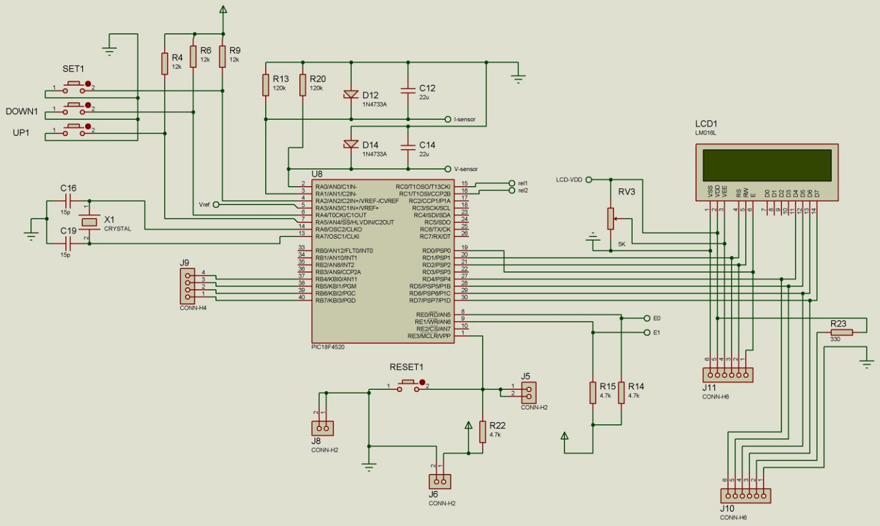

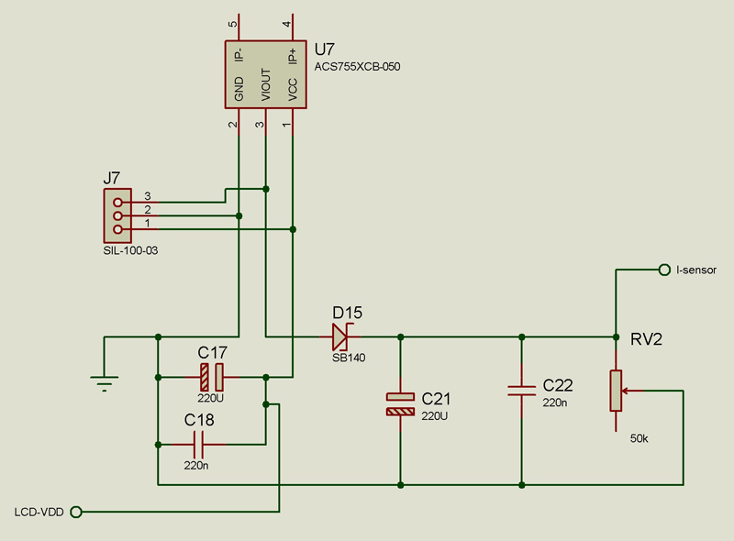

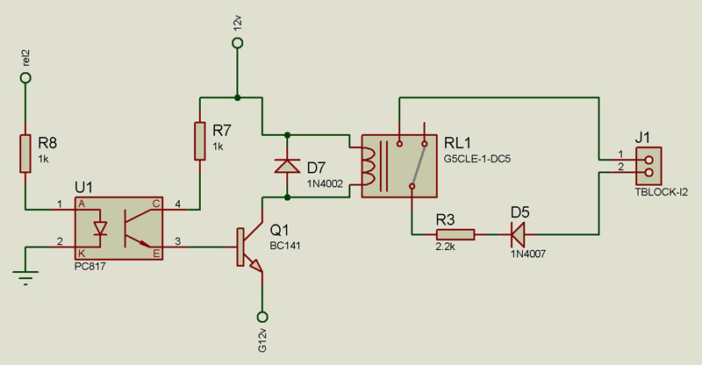

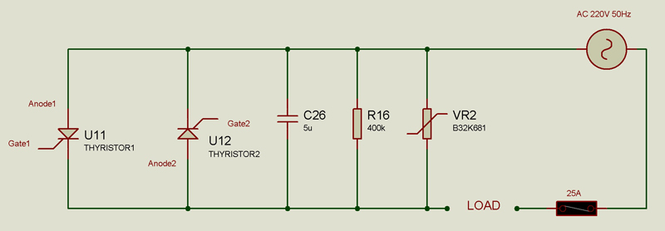

شکل 1- شماتیک مداری بخشهای مختلف سیستم

شایان ذکر است با توجه به توضیحات ارائه شده توسط متقاضیان گرامی، نمونه ای اولیه از سیستم حاضر ساخته شده و در همین راستا تصاویری از آن نیز فرستاده شده است. این تصویر در شکل 2 آمده است.

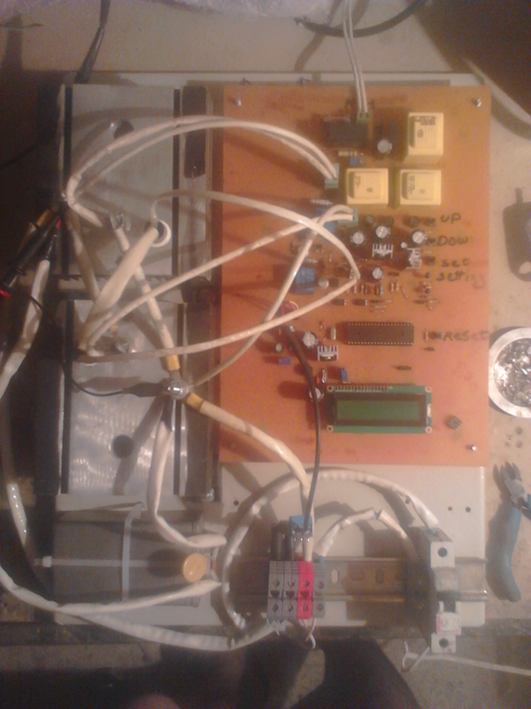

شکل 2- تصویری از نمونه ساخته شده

# بررسی میزان نوآوری

ویژگی‌های تقاضانامه

1. ارائه سیستمی برای محافظت اهمی از مدارات الکتریکی با مقاومت متغیر، شامل:

پردازنده مرکزی

سنسور سنجش جریان اثر هال

صفحه نمایش

بخش کاکنتورها

1. سیستم ارائه شده با توجه به ویژگی (1) که در صورت عبور اهم المان تحت محافظت از محدوده مجاز، جریان الکتریکی اعمال را به کمک کانکتورهای موجود قطع می کند
2. سیستم ارائه شده با توجه به ویژگی (1) که در آن مقدار اهم مجاز المان تحت محافظت توسط کاربر قابل تنظیم است.

مقایسه با دانش پیشین (Prior art)

* در مراجع (Pat1-Pat5) سیستم هایی ارائه شده است که اهم المان مقاومت متغیر را اندازه گیری می کند و متناسب با مقدار اهم آن، عکس‌العمل مشخص را انجام می دهد. به طور مشخص سیستم ارائه شده در مراجع (Pat1-Pat4) وظیفه تشخیص اهم المنت یا هیتر الکتریکی را دارد و با توجه به اهم اندازه گیری شده، دستور به قطع و وصل جریان اعمالی می شود. در این میان سیستم های ارائه شده در مرجع (Pat1 و Pat4) دارای میکروکنترلر هستند و کاربر می توان محدوده اهمی مجاز را در آن وارد نماید. البته این محدوده اهمی مجاز می توان به صورت غیر مستقیم باشد. به عبارتی کاربر مقدار دمای مطلوب را وارد می کند و سیستم اهمی را که هیتر در دمای مطلوب به آن می رسد را محاسبه می نماید و از آن بهره می برد.
* برای مثال در مرجع (Pat1) سیستمی برای کنترل دما در دستگاه هویه ارائه شده است. در این سیستم کاربر دمای مطلوب برای نوک هویه را در حافظه میکروکنترلر وارد می نماید. سپس میکروکنترلر بر اساس مقاومت هیتر، دمای نوک هویه را تشخیص می دهد و متناسب با آن جریان اعمالی به هیتر هویه را کنترل می نماید. در این دستگاه یک ترموکوپل دیجیتال نیز قرار دارد که وظیفه کالیبراسیون سیستم را دارد. در واقع در این حالت کاربر نوک هویه را در روی ترموکوپل دیجیتال قرار می دهد و دستگاه دما نوک هویه و مقاومت هیتر را می خواند و این دو را به هم بسط می دهد. شکل 3 شماتیکی از اجزای کلی این سیستم را نشان می دهد.

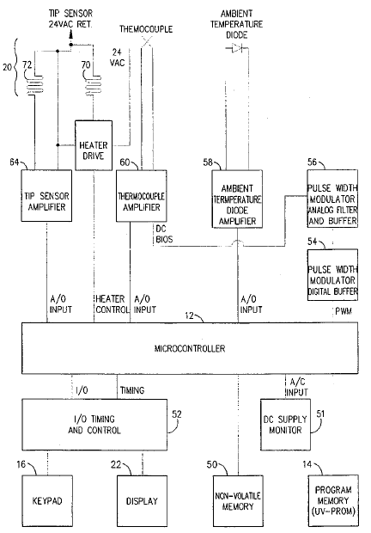

شکل 3- بلوک دیاگرام اجزای کلی سیستم ارائه شده در مرجع (Pat1)

* در مرجع (pat4) سیستمی برای کنترل دمای هیترهای الکتریکی ارائه شده است. در این سیستم با کمک مقاومت الکتریکی و دیگر پارامترهای الکتریکی، دمای هیتر تشخیص داده می شود. بعد از نصب هیتر، مقاومت آن در دمای مطلوب توسط سیستم خوانده می شود و در حافظه میکروکنترلر ذخیره می شود. در هر لحظه مقدار مقاومت الکتریکی این هیتر ها سنجیده می شود و با مقاومت دمای مطلوب مقایسه می شود و متناسب با آن ولتاژ اعمالی به هیترها کنترل می شود. شکل 4 شماتیکی کلی از سیستم پیشنهادی را نشان می دهد.

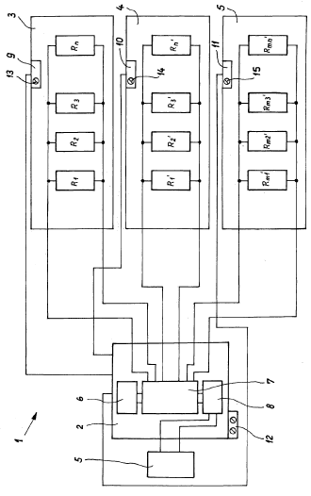

شکل 4- شماتیک کلی از سیستم پیشنهادی در مرجع (pat4)

* در مرجع (Pat3) روشی برای کنترل ولتاژ اعمالی به یک هیتر الکتریکی ارائه شده است. این روش بصورت آنالوگ می باشد و از میگروکنترلر استفاده نمی کند. در واقع در این مدار، هیتر الکتریکی توسط ترایاک تغذیه می شود. تغییرات مقاومت الکتریکی هیتر موجب تغییر در زاویه آتش ترایاک شده در نتیجه مقدار ولتاژ اعمالی به آن تغییر می کند. شکل 5 شماتیک مداری سیستم پیشنهادی را نشان می دهد

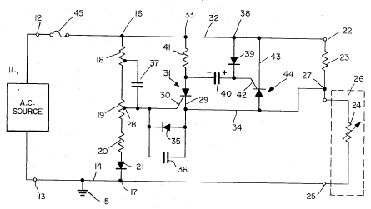

شکل 5- شماتیک مداری سیستم ارائه شده در مرجع (Pat3)

* در مرجع (Pat6) مداری برای تشخیص تغییرات اهم در یک مدار مقاومت متغیر ارائه شده است. این سیستم از میکروکنترلر بهره نمی گیرد. در واقع این مدار مبتنی بر یک جفت ترانزیستور است که بیس آنها به زمین متصل شده است و پایه های امیتر آن به دو سر المان مقاومت متغیر متصل می شود. در واقع در این مدار هدف این است که چگالی جریان المان مقاومت متغیر همیشه ثابت باشد و روشی برای محافظت و قطع مدار ارائه نشده است.
* در مرجع (pat7) سیستمی برای کنترل المان های الکتریکی با توجه به اضافه جریان ارائه شده است. در واقع در این مراجع مقدار جریان مصرفی المان سنجیده می شود و در صورتی که جریان مصرفی از مقدار مجاز تجاوز نماید دستور به قطع آن می دهد. در این مرجع نیز جریان مجاز توسط کاربر قابل تعریف است. به هر حال در این مرجع از سنجش اهم المان برای محافظت از آن بهره گرفته نمی شود. شکل 6 شماتیک کلی سیستم پیشنهادی در این مرجع را نشان می دهد

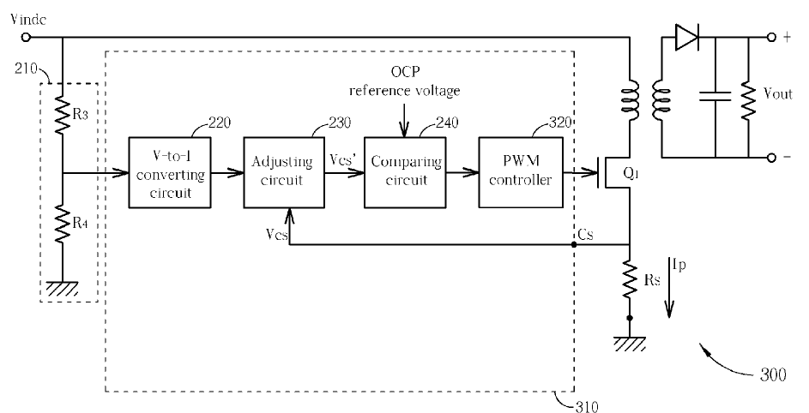

شکل 6- شماتیک کلی اجزای سیستم ارائه شده در مرجع (Pat7)

* استفاده از سنسور اثر هال برای تشخیص جریان عبوری جز دانش پیشین است. برای نمونه در مرجع (Ar1) استفاده از این سنسور برای تشخیص جریان عبوری از هادی افشا شده است. در واقع در این مرجع اصول کارکرد سنسور اثر هال تشریح شده است. بلوک دیاگرام کلی چند مدار موجود برای خوانش جریان نیز ارائه شده است.
* بنابراین بر طبق توضیحات و مراجع مذکور، نوآوری این تقاضانامه در جزئیات نظیر استفاده از سنسور اثر هال در محافظ اهمی است.

# بررسی میزان گام ابتکاری

همانطور که تشریح شد محافظ از المان مقاومت متغیر (به ویژه هیتر یا المنت الکتریکی) با توجه به مقدار اهم آن در مراجع پیشین افشا شده است. در این مراجع از روش های گوناگونی برای تشخیص مقدار اهم المان استفاده شده است. همچنین در برخی از این مراجع از میکروکنترلر به منظور پردازش داده ها و ذخیره سازی اهم مجاز المان افشا شده است. از طرفی استفاده از سنسور اثر هال برای سنجش مقدار جریان عبوری از هادی نیز جز دانش پیشین است. هر چند که از این سنسور در مدارات محافظ اهمی المان با مقاومت متغیر استفاده نشده است. اما به هرحال، درصورتی طرحی می تواند از دید شخص دارای ordinary skill در این زمینه، دارای خلاقیت کافی جهت پتنت شدن باشد که اثبات شود این طرح دارای نتایج غیرقابل پیش بینی (unexpected results) یا دارای موفقیت تجاری (commercial success) و یا مرتفع کننده مشکل فنی باشد که در این زمینه بصورت طولانی مدت وجود داشته است (long standing problem). لذا با توجه به اینکه ویژگی های اصلی این طرح در مراجع پیشین افشا شده است. لذا این اختراع از نقطه‌نظر شخصی که در این زمینه ordinary skill دارد دارای گام ابتکاری لازم جهت پتنت شدن نیست.

# بررسی امکان پیاده‌سازی (صنعتی‌سازی)

متقاضیان گرامی نقشه های مداری و شماتیکی سیستم پیشنهادی را ارائه نموده اند و نمونه ای از این سیستم را نیز ساخته و مورد ارزیابی قرار دادند. با توجه به نقشه های ارائه شده به نظر نمی رسد مرحله پر هزینه یا پیچیده ای برای پیاده سازی این طرح وجود داشته باشد. بهرحال قضاوت دقیق در این زمینه نیازمند مطالعه و بررسی بیشتر است

# کلیدواژه‌های استفاده شده برای جستجو

(Ohmic or resistance? or resistor? or ohm+); (protect+ or measure+ or isolat+ or Monitor+ or evaluat+ or control+); (adjustable or adjust+ or tun+ or set+ or chang+ or config+ or vari+); (electric+ or electronic+); (circuit or heater or heat+ or element+ or component+ or consum+ or coil+ or item?); (hall_effect? or hall_effect_sens+ or current_sens+ or (hall 1d effect 1d sens+) or (hall 1d current 1d sens+)); (lcd or microcontroller? or microprocessor?); heater Ohmic protector circuit; Ohmic protector circuit; protecting electrical component based on resistance; control a system based on resistor; variable resistance circuit electronically protector; circuit resistance control using hall effect;

# مقایسة‌ مراجع مشابه

## مقاله‌های مشابه

|  |
| --- |
| **Title**: Sensing Elements for Current Measurements |
| **Data Base**: google.com  **Citation/URL**: https://www.renesas.com/doc/whitepapers/amplifiers/current-sense-measurements.pdf |
| **There are many choices of sensing elements to measure current to a load, and the choices of current sensing elements can be sorted by applications, as well as the magnitude of the current measured. This in-depth write up discusses three different types of current sensing elements.**  **• First, we’ll focus on evaluating current measurements using a shunt (sense) resistor. We’ll explain how to choose a sense resistor and discuss the inaccuracies associated with the sensing element and extraneous parameters that compromise the overall measurement.**  **• Then, we’ll evaluate a direct current resistance (DCR) sensing architecture that allows for lossless current sense in some power applications. We’ll explain how to design a DCR circuit for power applications, analyze the drawbacks of the architecture and provide a way to improve the current measurement technique through calibration.**  **• Finally, we’ll cover measuring current by way of a Hall Effect sensor, explain how a Hall Effect sensor works and discuss the drawbacks of the technology and recent improvements in the technology.**  Shunt resistors are the most versatile and cost effective means to measure current. A shunt resistor cost ranges from a few pennies to several dollars—its price is differentiated by value, temperature coefficient, power rating and size. Shunt resistors commonly increase in cost for lower temperature coefficient (TC) and for higher power rating, while offering precision features in a small package size.  In choosing a sense resistor value, the full scale voltage drop across the sense resistor and the maximum expected current measured for the application has to be known.  When possible, the voltage across the sense resistor should be kept to a minimum to lower the power dissipated by the sensing element. Low power dissipated by the sense resistor limits the heating of the resistor. A small temperature change to the sensor resistor results in a smaller resistance change versus all current sensing values. The stability and accuracy of the sense resistor versus all currents improves with a constant value shunt resistor.  For most current sensing applications, the minimum and maximum measurable currents are known. The designer chooses the allowable voltage drop across the shunt resistor. For this discussion, assume the current measured is bidirectional. The max shunt voltage is chosen as ±80mV. Assume the max measured current is ±100A. The shunt (sense) resistor value is calculated using Connecting Sense Traces to the Current Sense Resistor Ideally, a four terminal current sense resistor would be used as the sensing element. Four terminal sensor resistors can be hard to find for specific values and sizes. Often a two terminal sense resistor is designed into the application.  Sense lines are high impedance by definition. The connection point of a high impedance line reflects the voltage at the intersection of a current bearing trace and a high impedance trace.  The high impedance trace should connect at the intersection where the sense resistor meets the landing pad on the PCB. The best place to make a current sense line connection is on the inner side of the sense resistor footprint. The illustration of the connection is shown in Figure 8. Most of the current flow is at the outer edge of the footprint. The current ceases at the point the sense resistor connects to the landing pad. Assume the sense resistor connects at the middle of the each landing pad. This leaves the inner half of the each landing pad with little current flow. With little current flow, the inner half of each landing pad is classified as high impedance and perfect for a sense connection.  Shunt Resistor Summary **Using a sense resistor to measure current is straight forward as long as proper care is taken with respect to layout and in choosing a sense resistor. The power rating and temperature coefficient parameters of a sense resistor are critical for designing a high accuracy current measurement system. With the knowledge of Ohm’s law, sense resistors are easy to design with. A drawback of the technology is that a sense resistor consumes power which eats into voltage headroom and lowers the efficiency of some applications.**  Element 2: Direct Current Resistance DCR circuits are commonly used in low supply voltage applications where the voltage drop of a sense resistor is a significant percentage of the supply voltage being sourced to the load. A low supply voltage is often defined as any regulated voltage lower than 1.5V A DCR sense circuit is an alternative to a sense resistor. The DCR circuit utilizes the parasitic resistance of an inductor to measure the current to the load. A DCR circuit remotely measures the current through an energy storing inductor of a switching regulator circuit. The lack of components in series with the regulator to the load makes the circuit lossless.  Inductors are constructed out of metal. Metal has a high temperature coefficient. The temperature drift of the inductor value and the parasitic resistance (Rdcr) could cause the DCR circuit to be un-balanced. The change in the inductor value and parasitic resistance could be a result of either self-heating due to current passing through the inductor or environmental temperature rise. Copper has a resistive change of 3.9mΩ/C. The change in inductor wire temperature directly impacts the value of Rdcr.  Designing a DCR circuit without tuning capabilities can result in a current measurement error of up to 35% due to the variance of the inductor and capacitor within the DCR circuit. Figure 12 plots measurement error versus different inductor and capacitor tolerance values. The measurement errors could increase to approximately 50% when including the Rdcr variation.  A simple trimming circuit utilizing a non-volatile digital potentiometers (DCP) drastically improves the current measurement accuracy.  The procedure for measuring the system resistance is to measure the voltage change across the sense capacitor, Csen, when Rtest is connected and not connected. The value of Rtest should be chosen such that the current change is measureable. Changing the current by 10% of the nominal current is a good current change to design for. If the current change is too high with respect to the nominal current, the resistance of Rdcr will change due to the additional current heating the DCR resistor. A current change too low will result in an unreadable current change.  DCR Summary **A DCR circuit is a lossless circuit that requires little board space to construct. The circuit requires tuning for proper operations. Therefore, extra steps need to be taken at the manufacturing to guarantee proper operation of the circuit. The tolerances of the reactive components can cause large variances in the effective resistance between circuits. Inductors and capacitors have strong temperature coefficients which add to the inaccuracies of the circuit once it is tuned. Overall, the DCR circuit architecture is good for measuring gross currents while maintaining a lossless system for switching regulators.**  **Element 3: Hall Effect Sensor A Hall Effect sensor measures the strength of a magnetic field from a nearby conductor in determining the magnitude of the current passing through a conductor. Hall Effect sensors that measure current are commonly found in lossless and very high current applications. A Hall Effect sensor remotely measures current passing through a conductor by measuring the magnitude of the magnetic field sourced from a trace. Systems in which employ Hall Effect sensors are considered lossless since the sensor remotely measures current. Applications above 200A may use Hall Effect sensors because the power dissipation from a sense resistor is large for high current applications. Figure 15 illustrates the basic concept of a Hall Effect current measuring application.**    The mathematical relation between the magnitude of the current and the magnetic field is represented in Equation 16 for a wire. A strip line trace has a slightly different equation. For simplicity, this paper uses Equation 16 to discuss the relationship between current and magnetic fields.  BμoI⋅2π⋅r⋅ORI2π⋅r⋅B⋅μo Equation 16. The Mathematical Relationship between Current and Magnetic Field for a Wire μ0 is the permeability of the magnetic field. The permeability value, μo, of free space equals 4π*10-7 H/m. The value r is the distance in meters between the conductor and the linear Hall Effect sensor. The variable I is the current flowing in amps through the conductor. B is the magnetic field in Gauss.  From Equation 16, the strength of the magnetic field diminishes as the spacing between conductor and sensor increases. A linear Hall Effect sensor converts the magnetic field measured into either a current or a voltage. The gain of the sensor is reported as either mV/G or mA/G. Some manufactures report the gain in Teslas. A Tesla equals 10,000 Gauss.  Suppose a 200A current flows through a trace that is 0.03m from the center of the trace to the center of the of Hall Effect chip. What is the expected magnetic field at the center of the sensor? If the sensor has a gain of 5mV/G, what is the output voltage of the sensor? The environment in which the current bearing trace and the sensor are subjected to is important for measuring weak magnetic fields. A linear Hall Effect sensors measure the total available magnetic field at the set location. Current bearing traces routed near the sensor will change the magnetic field at the sensor and ultimately change the accuracy of the measurement. The sensor will also measure changes in the environmental magnetic fields. A change in the environmental magnetic field could be caused by a switching motor or any device that radiates energy.  **A magnetic shield that encapsulates the current bearing trace and the Hall Effect sensor is a means to controlling the magnetic field in the sensor’s environment. Figure 18 illustrates a metal case enclosing the trace and sensor. The enclosure is known as a Faraday cage.**  The shield in Figure 18 should be grounded since ground is usually the most stable and lowest impedance to which most circuits are referenced.  Recently, Hall Effect sensors that integrate the current conduction path, provide environmental shielding and temperature compensation circuitry in a single package have been released to market. The integration of the current conduction path simplifies the gain calculation between the current flowing through the conductor and the output voltage. The single chip solution simplifies the layout and the design of a Hall Effect sensor measuring application because a user does not have to worry about the conductor to sensor spacing and the environment the sensor is in. Figure 19 is a simplified circuit of the integrated solution The integrated conduction path (IP+, IP-) has a resistance ranging from 0.1mΩ to 2mΩ. The current sense in Figure 19 is not a lossless system because of the loss associated with integrated conduction path.  Hall Effect Sensor Summary Hall Effect technology has improved recently allowing for easier design-ins, better accuracy and better noise immunity. While there have been advancements, the strength of the technology resides with high current applications. A Hall Effect sensor dissipates less power than a shunt resistor.  **Conclusion In this in-depth paper about evaluating current sensing elements, it was learned that no one sensor is the choice solution for all applications. Shunt resistors are the most widely used current sensing element due to the simplicity of the design, precision of the measurement and cost of the solution. Direct Current Resistance (DCR) sensing is useful in switching regulator applications with low regulation voltages because current is measured remotely. Finally, Hall Effect sensors are suitable for high current applications where the power dissipation of a shunt resistor is greater than a Hall Effect solution.**  **For every positive about a sensing element, there is a drawback. Shunt resistors dissipate power resulting in power efficiency reductions. The voltage drop associated with current flowing through the shunt resistor consumes valuable voltage headroom in low voltage applications. A DCR sensing circuit specialty is to sense current remotely in switching power applications. A DCR circuitry is dependent on matching of a capacitor and an inductor. Both components have loose tolerances and high temperature coefficients. A Hall Effect sensor is susceptible to environment noise and design challenges. Advancements have been made in the technology but measurement accuracy is still a limitation.** |
| **شباهت‌ها و تفاوت‌ها:** در این مقاله برخی از روش های موجود برای اندازه گیری جریان عبوری از هادی الکتریکی تشریح شده است. یکی از این روش ها استفاده از سنسور اثر هال است. در این مقاله اصول پایه و روابط حاکم بر روی این سنسور ها تشریح شد. همچنین دیاگرام کلی مدار مورد نیاز برای این سنسور نیز مورد بررسی قرار گرفت. |

## پتنت‌های مشابه

|  |
| --- |
| **Title**: Soldering apparatus processor having temperature selection, calibration and heating control of tip |
| **App./Pub. No.**: US5495093 |
| **A soldering system is disclosed having a stored program microcontroller by which one or more temperatures can be selected for a soldering iron tip. The system then automatically maintains such tip temperature during the soldering operation. The programmed microcontroller is coupled through input/output and interface circuits to a heating control that in turn is connected to the iron heater element for switching AC power in units of full waveform cycles across the element while the temperature of the tip is measured by a resistor sensor and an associated bridge measurement circuit so as to produce a signal that is applied to an input of the microcontroller forming a feedback loop. This causes the resistor sensor and hence the iron tip to reach the desired temperature. A thermocouple is provided for measuring and calibrating the actual temperature of the iron tip thus ensuring that the resistor sensor and associated feedback loop causes the microprocessor to drive the heater element as needed to cause the soldering tip to stabilize at the selected temperature. The external thermocouple probe may also be used separately and simultaneously with the soldering operation to ensure that the temperature of a probed component does not exceed a predetermined safe level.**  Thus, in accordance with the preferred and exemplary embodiment of the invention, a soldering system having a stored program processor is provided in which one or more temperatures of a thermoelectric load, such as the heating element and associated tip of a soldering iron, can be selected. The system then automatically maintains such temperature during the soldering operation. In the preferred embodiment, the processor is a microcontroller means, the operation of which is governed by a stored program in a PROM. The programmed microcontroller is coupled through input/output and interface circuits to a heating control that in turn is connected to the thermoelectric load for driving the load to a temperature selected and entered on a keypad. The temperature of the tip is measured by a resistor sensor and associated bridge measurement circuit so as to produce a signal that is applied to an input of the microcontroller forming a feedback loop. This causes the resistor sensor and hence the iron tip to reach the desired temperature.  Also, in the preferred embodiment, a thermocouple is provided with the soldering station for measuring and calibrating the temperature of the actual tip of the iron thus ensuring that the resistor sensor and associated feedback loop causes the microprocessor to drive the thermoelectric load as needed to cause the soldering tip to stabilize at the selected temperature.  Still another and related aspect of the preferred embodiment is that the external thermocouple probe may be used independently and simultaneously with the soldering operation by touching the thermocouple probe to any heat sensitive component or surface near the joint being soldered to ensure that its temperature does not exceed a predetermined safe level for adjacent components.  **Other aspects of the preferred embodiment include the provision for a plurality of precision calibration processes and associated circuits for developing the control and measurement signals for such calibration processes. First, a low level amplifier means capable of measuring microvolts is provided as part of the input circuit to the microcontroller for measuring the output voltage of the external thermocouple. To calibrate this low voltage amplifier circuit and remove an offset voltage inherent in low voltage amplifier design, a calibration procedure is selected by a user entry on the keypad to bias out the low voltage offset on the thermocouple amplifier using a pulse width modulated output of the microcontroller. The thermocouple itself is also calibrated over its range of temperature values, for example, from 75° F. through 900° F. by a software driven menu that instructs the user to place the external probe thermocouple on a temperature standard, and successfully setting the standard to temperatures prompted on a display screen of the soldering station. Once the thermocouple has been calibrated, which may be needed only once a month or less frequently, a resistor sensor embedded in the soldering tip as a tip sensor, is calibrated by an automatic multi-temperature calibration routine that is simply started by user selection on the keypad and is henceforth carried out without user operations automatically as described more fully below.**  **Following calibration, the desired tip temperature setpoint is entered on the keypad. Thereupon, the microcontroller receives at one of its A/D conversion inputs the measured resistor sensor resistance and with scaling from stored calibration constants, drives the thermoelectric heater by a heater element drive TRIAC circuit under control of the microcontroller to the selected tip temperature.**  For multiple component soldering procedures, the user enters a plurality of preselected temperatures so that you need not memorize each of the temperatures required for a given multi-step process. By merely responding to menu prompts on the display the user quickly switches from one preselected temperature to another during the soldering procedure. Likewise, a plurality of different soldering iron tips and their associated thermo calibration characteristics are stored and retrieved by the microcontroller with the user keypad without requiring recalibration of the soldering iron each time its tip is changed. The preselected temperatures, tip memory calibration constants, and other changeable operating characteristics are safely stored in a non-volatile RAM device provided in the preferred embodiment and interfaced to the microcontroller for retaining these values when the power is turned off and for reinitializing the microcomputer or microcontroller when turned on.  Still another aspect of the preferred embodiment is to provide a security code routine in the microprocessor software enabling a supervisor or other person of authority to lock the device against changes to the various temperature and tip memory settings. The lock is releasable only upon entering the proper security code.  For the convenience and compactness of the soldering station, once the various temperature and tip selections are made on the station keypad, the user places over the keypad a protective cover that is formed with a recessed tray holding a tip-wiping sponge, and an iron holder is supported on top of the unit above the digital display for resting the iron when not in use. The front of the soldering station housing includes a receptacle into which the external thermocouple plugs into for either the calibration procedures described above or for using external thermocouple probe as a temperature measuring instrument during the soldering process.  It is thus seen that a very powerful computer processor regulates the temperature of the soldering tip to great precision and accommodates a very flexible schedule of temperatures and tips as well as provides for quick and highly accurate thermocouple calibration of the apparatus.  **With reference to FIGS. 1 and 2, a soldering apparatus 10 (FIG. 2) contains a built-in microprocessor or microcomputer provided in the preferred embodiment by microcontroller 12 (FIG. 1) having a stored program contained in program memory 14. In response to user entries on a keypad 16 (FIGS. 1 and 2), the processing of microcontroller 12 affords temperature selection, calibration, and heating control of tip 18 of soldering iron 20. The operating conditions, including temperature selection, tip type, calibration steps and operating performance including heating element duty cycle, are presented to the user in a convenient LCD digital diplay 22 (FIGS. 1 and 2). Apparatus 10 as shown in FIG. 2 includes a housing 24 having a regular polygon base with a front porch 26 on which keypad 16 sits to present a horizontal array of user keys, and toward the rear of the polygon base an integral portion of the housing rises vertically to mount in a generally vertical but rearwardly and upwardly inclined plane the digital display 22. On a rearwardly and downwardly sloping top surface housing 24 mounts a generally cylindrical soldering iron holder 28. Soldering iron or device 20 is coupled to the electrical circuits of apparatus 10 by a heater and sensor lead cord 30 and the entire apparatus is powered by standard AC current via a power cord 32. At a front panel 34 of housing 24, a thermocouple attachment receptacle 36 removably accepts a plug 38 that is connected over a cable 40 to the crosswires of a thermocouple temperature measuring device 42 for the iron tip, or optionally to an elongated thermocouple general use probe 44. Thermocouple device 42 is configured to measure the actual tip temperature of device 20 by placing tip 18 at the crosspoint of the thermocouple wire junction for calibration purposes and the optional probe 44 is used as described below in a temperature measuring method during the soldering process. A generally rectangular cover 46 fits over keypad 16 and provides a tray recess on the upper surface for holding a tip-cleaning sponge. Cover 46 is simply pulled off of the apparatus to access keypad 16.**  All of the electronics, including the power supply, are contained within housing 24 and may be mounted on a printed circuit board (not shown) for ease of assembly and repair. With reference to FIG. 1, microcontroller 12, program memory 14, here in the form of an IUV erasible programmable ROM (or PROM), a non-volatile memory 50, IO timing and control 52, pulse width modulator digital buffer 54 and an associated pulse width modulator analog filter and buffer 56, ambient temperature diode amplifier 58, thermocouple amplifier 60, heater driver 62 and tip sensor amplifier 64, and a DC supply monitor 51 are all contained as discrete or large scale integrated circuitry within housing 24 to select, regulate and calibrate the temperature of the soldering device 20, and to measure temperature using thermocouple probes 42 and 44. Other functions are provided as described more fully below. The temperature of tip 18 of soldering device 20 is obtained by driving a thermoelectric load or heater element 70 contained within the protruding cylindrical nose of device 20. Mounted in close proximity to element 70 on device 20 is a tip sensor element 72 in the form of a resistor sensor which, as indicated in FIG. 1, is combined in a circuit with heater driver 62 and tip sensor amplifier 64. An alternative configuration uses a single resistive element for both heater and sensor functions as shown in FIG. 7.  **With reference to FIGS. 3A and 3B, the microprocessor, or it can be called a microcomputer, of apparatus 10 is, in the preferred embodiment, an 8098 microcontroller available from Intel Corporation of Santa Clara, Calif., and includes in addition to the basic microprocessor functions an internal RAM, A-to-D 10 bit conversion, pulse width modulation (PWM) output and A/D multiplexing. A crystal controlled clock circuit 80 regulates the basic clock timing of microcontroller 12 and a divider filter circuit 82 provides a reference DC input to an A-to-D converter input 41 of microcontroller 12 for monitoring power supply level. The microcontroller is reset on powerup by reset compacitor 81.**  Heater drive 62 is shown in FIGS. 3A and 3B as TRIAC switching circuits 62a and an electro-optical isolator and logic circuit 62b. TRIAC switching circuit 62a includes a TRIAC device 100 having a lead 102 that is triggered through the electro-optical isolator and logic circuit 62b in response to trigger timing output signals from microcontroller 12 over lead 104. The timing of these triggers is software controlled so as to cause the anode-cathode main current channel of TRIAC 100 to conduct full cycles of a 24 volt AC source through heater element 70 over a lead 106, denoted heater hi, and a return lead 108 connected across a 24 volt unfiltered secondary of a 24 volt power supply transformer 110, the primary of which is connected to standard alternating current supply. The cathode lead 112 of the TRIAC 100 is also connected through a resistor R1 and terminal junction J6 across an LED indicator 114 to display the powered condition of heater 70 when switch TRIAC 100 is triggered on. Circuit 62b includes electro-optical isolator 116 in which the control input terminal 2 receives a logical low signal from NAND gate 118 in response to the output of microcontroller 12 over lead 104. Isolator 116 through the optical communication path drives the TRIAC gate through resistor 120 and trigger lead 102 switching the TRIAC "on" at times determined by the software program operating microcontroller 12 and a zero crossing detector circuit 62c to ensure switching only at the zero crossings of the 60 cycle 24 volt AC power source. The number of full cycles of 24 volt AC power delivered by the switched TRIAC to the heater element 70 is also determined by the software program operating microcontroller 12 in response to the feedback control loop using tip sensor 72 and a bridge measurement circuit 64 described below. Electro-optical isolator 116 prevents interference between the relatively high current switching operations of TRIAC 100 and the sensitive low level logic and control signals associated with the microcontroller 12. NAND gate 118 is normally enabled to respond to the high speed output HS01 from microcontroller 12 over lead 104 by an inverter 122 having a heater enable signal through terminal 6 of J3 to power supply ground. This can be disabled by opening the ground lead to disable NAND gate 118 and hence prevent triggering of the electro-optical isolator for trouble shooting and test purposes only. Normally, NAND gate 118 is enabled for all normal operating conditions.  While the TRIAC triggering circuit through electro-optical isolator 116 determines the actual triggering time duration, a zero crossing detector circuit 62c of the heater drive 62 monitors the 24 volt AC source over lead 130 and applies an interrupt at external interrupt terminal 47 of microcontroller 12 to initiate the heater cycle as well as initiate measurement of tip sensor 72. For this purpose, cross-over detector circuit 62c includes a CMOS logic buffer 132 having an input connected to a parallel capacitor diode network 134 coupled through an input resistor 136 to the 24 volt AC lead 130. A clamping diode 138 connected to positive 5 volt DC limits the voltage swing at the input to buffer 132. In operation, circuit 62c looks at the 24 volt alternating current cycle and whenever the voltage level relative to ground D drops below 2 volts, the output of buffer 132 goes low, and when the AC waveform climbs above 2 volts the high going output of CMOS buffer 132 triggers the external interrupt. The heater drive subroutine of microcontroller 12 as described further below takes over and provides the necessary timing for ensuring that an integral number of full cycles of AC heater voltage are applied to the heater by operating TRIAC 100 through the electro-optical isolator 116 in response to high-speed output 01 over lead 104 as described above. In other words, the zero crossing detector circuit 62c, in combination with the internal timing of microcontroller 12, establishes the proper turn on/turn off time of the heater element 70. The switching of TRIAC 100 occurrs at substantially zero crossing (i.e., less than 2 volts) to minimize switching transient and hence safeguard the sensitive digital and analog circuitry from unwanted biasing and switching noise.  Turning now to the tip sensor amplifier shown as circuit 64 in FIG. 3a, a balanced bridge formed on one side by the legs of resistor R1 and the resistance of resistor sensor 72 with the other branch legs of the bridge being resistors R3 and R4. Sensor 72 is connected via terminal J4 over leads 140 and 142 as indicated. A voltage appearing across the bridge between junction 144 and 146 causes an input to terminals of IC amplifier 148 having associated RC feedback and filtering consisting of C1, R2 and C2, R6 and R5, and C3. The bridge output representing the resistance of resistor sensor 72 and hence, when calibrated and scaled, the temperature of the soldering iron tip is applied as an analog signal to A-to-D converter input ACH4 at terminal 43 of microcontroller 12. When the heater is used as the sensor, as shown in the alternative embodiment of FIG. 7, the shunt around Diode D1, appearing in FIG. 3A, is removed so that Diode D1 is placed in the bridge circuit to prevent the heater voltage from being applied through the sensing bridge to the 5 volt reference. Diode D3 shunted in FIG. 3B in the other branch of the bridge is likewise placed in the circuit by removing the shunt for the embodiment of FIG. 7 to balance out the voltage drop across D1, equalizing the branches of the bridge. |
| **شباهت‌ها و تفاوت‌ها:** در این پتنت یک دستگاه هویه الکتریکی ارائه شده است. در این هویه به منظور تشخیص دمای نوک هویه از سنجش مقاومت هیتر آن کمک می گیرد. در واقع بعد از کالیبراسیون دستگاه توسط ترموکوپل دیجیتال تعبیه شد. سیستم مقدار مقاومت هیتر را می سنجد و این مقدار مقاومت را به دمای نوک هویه بسط می دهد. |

|  |
| --- |
| **Title**: Temperature control circuit employing a variable resistance heating element |
| **App./Pub. No.**: US3679871 |
| **The present circuit employs a heating element whose electrical resistance varies in response to the heat generated thereby. The heating element comprises one leg of a bridge circuit and the output signal from the bridge circuit is connected to fire a silicon-controlled rectifier. The silicon-controlled rectifier is connected to short out a leg of the bridge circuit which is serially connected to the heating element thereby providing full power for energizing the heating element when the siliconcontrolled rectifier is turned on and simply providing control current to the heating element when the silicon-controlled rectifier is turned off.**  SUMMARY The present circuit is taught in both the half-wave and fullwave mode of operation. The circuit employs an alternating current signal source connected to a bridge circuit. One leg of the bridge circuit is the heating element which provides heat to the utility device. The heating element is fabricated from a material having a positive temperature coefficient such as Balco wire, manufactured by the Driver-Harris Co. It should be understood that other materials such as nickel iron alloys may be used as heating elements, the prerequisite being that the heating element should have a useable change in resistance with a change in temperature. In series connection with this last mentioned leg there is a large valued resistor which constitutes a second leg of the bridge circuit. Across this second leg of the bridge circuit is connected a silicon-controlled rectifier which has a control element further connected to the tap of a variable resistor. The setting of the variable resistor represents the setting of the desired temperature. When the temperature of the heating element is colder than the desired temperature (and this example presupposes that the device prior to heating is changing from a relatively warm condition to a relatively cold condition) the bridge circuit will provide a difference of potential across the control element and the cathode element of the silicon-controlled rectifier, thereby turning on the silicon-controlled rectifier. When the silicon-controlled rectifier conducts it will short circuit" the above-mentioned second leg of the bridge circuit thereby providing full power across the heating element.  If the system is operating in the half-wave mode of operation the heating element will be turned on only during every other half cycle, if indeed the temperature condition of the device warrants that the circuit is to be turned on at all. On the other hand, if the circuit is operating in the full wave mode of operation, the heating element will be turned on during every half cycle in which the heating element, acting as a sensor, determines that heat is needed. In both modes of operation, the circuit provides that one side of the line can be grounded so that there is no need to double-fuse the circuit arrangement to provide a safety factor (for the components of the circuit) against a heavy surge of current resulting from a spurious circuit connection.  **Consider FIG. 1 wherein there is shown an alternating current signal source 11 connected to the terminals 12 and 13. It will be noted that the terminal 13 is connected to the line 14 which is further connected to ground 15. Accordingly, then the line 14 is the grounded line of the circuit arrangement. Further it will be noted that the terminal 12 is connected to a fuse 45 the purpose of which is to protect components of the circuit in the event that some one or more portions of this circuit become grounded or shorted independent of the ground connection to line 14.**  **Since the circuit in FIG. I has already been indicated as a circuit which operates in the half-wave mode of operation, let us consider the circuit only as it operates during the positive half cycles of the applied alternating current signal source. During a positive half cycle there would be a voltage applied between the terminals 16 and 17 which would assume the voltage polarities shown in FIG. 1. Accordingly, there would be current passing from the tenninal 16 through the resistors l8, 19, 20 and the diode 21 to the terminal 17. At the same time the same voltage would be applied to the upper terminal 22 (of the resistor 23) across the resistor 23 and the heating element 24 to the terminal 25. The heating element 24 is shown as a variable resistor to indicate that the electrical resistance of the heating element 24 varies in response to its change in temperature. The heating element 24 is located to heat up the utility device 26. As indicated earlier, in the preferred embodiment, the heating element 24 is made from Balco wire manufactured by the Driver-Harris Company although other forms of heating elements can be used provided that the heating element has a positive coefficient of temperature.**  If the circuit of FIG. 1 is studied it can be seen that there is a bridge circuit which is composed of the resistor 18 and a portion of the resistor 19, constituting one leg; the remainder of resistor 19 is in series connection with the resistor 20 and the diode 21, constituting a second leg; the resistor 23 constituting a third leg; and the heating element 24 constituting the fourth leg. The output signal from the bridge circuit just described can be obtained by connecting a circuit to the terminal 27 and to the tap 28 of the adjustable resistor 19. Actually the tap 28 represents a dial which can be set to obtain the desired temperature at which the system should operate as will become apparent hereinafter. The output signal from the bridge circuit is connected across the cathode 29 and the control element 30 of the silicon-controlled rectifier 31. The anode of the siliconcontrolled rectifier 31 is connected to the upper line 32 at the terminal 33.  As should be apparent, in accordance with the theory of operation of a bridge circuit, if the electrical resistance value of resistor 23 is equal in value to the resistors 18 plus the portion of the resistor 19 which makes the first leg of the left hand side of the bridge and if the electrical resistance of the heating element 24 equals the electrical resistance of the lower half of the resistor 19 plus the resistor 20 and the electrical resistance of the diode 21 then the bridge circuit will be balanced and there will be no difference in potential across the control element and the cathode element of the silicon-controlled rectifier 31. Accordingly, the silicon-controlled rectifier 31 will not conduct or fire. It is also well understood that the changing of the electrical resistance in any of the bridge legs will generate a difference of potential across the control element and cathode element of the silicon-controlled rectifier 31. For instance, if the tap on the resistor 19 is changed by a new setting of the dial, the bridge will become unbalanced and there will be a difference of potential across the control element and the cathode element of the silicon-controlled rectifier 31, thereby causing it to conduct.  Consider a situation wherein the tap 28 has been set to a desired temperature value (which is translated into a resistance value through the variable resistor 19) and further wherein the utility device 26 is relatively cold thereby indicating a relatively cold heating element and hence a relatively low resistance for the heating element 24. At the beginning of the positive half-cycle there will be current flow between the terminals 16 and 17 and between the terminals 22 and 25. Since under the previously stated conditions the resistance of the heating element 24 is relatively low (the temperature being relatively cold) there will be a smaller voltage drop from the terminal 27 across the heating element to terminal 25 than there will be from the tap position 28 across the part of the resistor 19, the resistor 20, and the diode 21 to terminal 17. Ac- cordingly, the control element 30 will be positively biased with respect to the cathode 29 and the silicon-controlled rectifier will be turned on. Since the silicon-controlled rectifier 31 employed herein normally requires a .6 volt difference of potential to cause it to conduct there is some period of time that lapses between the zero crossover time of the positive half-cycle and the time at which the silicon-controlled rectifier does conduct. When this silicon-controlled rectifier conducts there is current flow from the terminal 33 through the silicon-controlled rectifier 31 along the line 34 to the terminal 27, through the heating element 24, to the terminal 25 and hence to the other side of the line. When the silicon-controlled rectifier 31 conducts the resistor 23 will be shorted out of the circult and full power from the alternating current source 11 is applied to the heating element 24 to cause the heating element to heat up in accordance with the proposition that I R= watts or heat.  Once the silicon-controlled rectifier 31 commences to conduct the cathode '29 will be at virtually the same potential as the point 33 and there would be a great tendency for internal arcing to take place between the cathode 29 and the control element 30 under these circumstances. Accordingly, the diode 35 is added to the circuit to permit current to be transmitted from the cathode 29 to the tap 28 and protect the silicon-controlled rectifier under these conditions. The capacitor 36 is simply added to take care of the high frequency signals which often occur under these conditions and to eliminate susceptability to power line noise.  The silicon-controlled rectifier 31 is like a thyratron, in that once it is turned on it will continue to conduct until either the anode or the cathode has had its voltage reduced to zero or removed. In the case under consideration of course the silicon-controlled rectifier 31 will conduct for the remainder of the positive half cycle and apply current to the heating element 24 to cause that element to produce heat. Now as the heating element 24 produces heat the temperature commences to increase and therefore its resistance increases. Hence the voltage at point 27 commences to increase in accordance with the increased voltage drop across the heating element 24. During the negative cycle which follows, the heating element will not generate heat but will retain some heat from the positive half-cycle experience. During the following positive half-cycles the heating element 24 will be subjected to repeated bursts of power and therefore will continue, on the positive half cycles, to generate heat thereby increasing its resistance value. When point 27 develops a potential value equal to the potential at the point 28 the silicon-controlled rectifier 31 will no longer conduct and hence the heating element (and the utility device 26) will be at the desired temperature.  **The system as just described operates quite satisfactorily but not in its most efficient mode for two reasons. in the first place since there has to be a difference of potential between the control element 30 and the cathode 29, the silicon-controlled rectifier may not fire until quite late in the cycle, i.e., when the amplitude of the voltage signal has risen substantially. In order to overcome this problem the capacitor 37 is connected into the circuit as shown to cause a phase shift whereby the voltage developed at the tap 28 leads the voltage developed at the tenninal 27. In this manner the silicon-controlled rectifier 31 can be turned on relatively early in the half cycle, thus making the system more efiicient. However, it will be noted that the capacitor 37 is connected in such a manner to the resistor 18 that the system will not operate on the zero crossover of the positive half cycle. This is necessary in order to provide a sufiicient amount of time to keep the resistor 23 in an unshorted condition or actively in the circuit to provide control current across the heating element 24. in other words, the point 27 should be subjected to a condition where there is current flowing across resistor 23 and the full bridge circuit is in operation in order to develop the control signal between the point 27 and the point 28. This occurs during the early part of the positive half cycle before the silicon-controlled rectifier 31 has been fired. It is during this early portion of the positive half cycle that the difference of potential between the control element 30 and the cathode 29 is developed if in fact it is going to be developed. Considering this operation further, if immediately prior to a given positive half cycle, the heating element 24 has been heated to a point where the resistance thereof develops a potential at point 27 which is equal to the potential at point 28, then the siliconcontrolled rectifier 31 will not fire or be turned on at any time during that positive half cycle. in effect it will be a half cycle during which time there will be no additional heat generated by the heating element 24, and the heating element 24 may in effect commence to cool in that half cycle or subsequent half cycles during which no heat is generated. Of course once the heating element 24 has cooled to a point where its resistance has diminished so that the voltage at point 27 becomes sufficiently negative (i.e., .6 volts in the preferred embodiment) relative to the voltage at the tap 28, then once again the silicon-controlled rectifier 31 will be turned on thereby shorting out the resistor 23 and applying the full power of the alternating current source to the heating element 24.**  1. A temperature control circuit comprising in combination.  first and second electrical energy input lines; first voltage divider circuit means having first and second terminals respectively connected to said first and second electrical energy input lines; heating member means having third and fourth terminals and being capable of being electrically energized to provide heat and having an electrical resistance characteristic which varies with the heat being so generated, said fourth terminal being connected to said second electrical energy input line; first electrical resistor means having fifth and sixth terminals, said sixth terminal being connected to said third terminal of said heating member means and said fifth terminal being connected to said first electrical energy input line; electrical current switching means having an input element, an output element and a control element, said input element being connected to said first electrical energy input line, first circuitry means connecting said output element to said third terminal and said control element being connected to said first voltage divider circuit at a variable point between said first and second terminals, whereby when there develops a predetermined difference of potential between said control element and said output element in response to the electrical resistance developed by said heating member means, said current switching means conducts electrical current to said heating member means thereby by-passing said first electrical resistor means and whereby when there develops a lack of said predetermined difference of potential, said current switching means is non-conductive; and voltage phase shifting means connected between a predetermined point on said first voltage divider circuit and said variable point whereby the voltage applied to said control element is out of phase with the voltage applied to said output element so that said current switching means can be switched relatively earlier in an applied electrical energy cycle than would occur without said out of phase condition.  2. A temperature control circuit according to claim 1 wherein there is included a second current switching means having an input element, an output element and a control element, said input element being connected to said first circuitry means, said output element being connected to said first electrical energy input line; second circuitry means connecting said control element of said second current switching means to said first electrical energy input line whereby a voltage is developed and stored thereby during the time when said first current switching means is conducting and characterized such that said developed voltage turns on said second current switching means during the time that said first current switching means is rendered non-conducting thereby conducting electrical current through said heating member from said second electrical energy line to said first electrical energy line.  3. A temperature control circuit according to claim 1 wherein there is further included a silicon-controlled rectifier having an input element, an output element, and a control elenected to conduct current between said first electrical energy input line to said capacitor to charge said capacitor whereby when said first current switching means is conducting said capacitor is charged in such a way that said silicon-controlled rectifier is biased to conduct in response to a polarity change of the electrical signal applied to said first and second electrical energy input line |
| **شباهت‌ها و تفاوت‌ها:** در این پتنت روشی برای کنترل ولتاژ اعمالی به یک هیتر الکتریکی ارائه شده است. این روش بصورت آنالوگ می باشد و از میگروکنترلر استفاده نمی کند. در واقع در این مدار، هیتر الکتریکی توسط ترایاک تغذیه می شود. تغییرات مقاومت الکتریکی هیتر موجب تغییر در زاویه آتش ترایاک شده در نتیجه مقدار ولتاژ اعمالی به آن تغییر می کند. |

|  |
| --- |
| **Title**: Control of electrical resistance-heating installation, measures resistance and controls power, current or voltage to adjust room- or body temperature |
| **App./Pub. No.**: DE10230509B3 |
| **During installation, the resistance of the heater is allowed to vary, being determined by the length of the resistance laid, and its connection in series and/or parallel. Following completion the resistance (and optionally other electrical properties) is measured using an instrument, and stored in a controller memory. The controller processes the measurement, to control a power, current or voltage, hence adjusting the temperature of a room or body.**  The object of the invention is to propose a method and a system of the aforementioned type, wherein / the heated economically as possible from the viewpoints of energy saving, a space or a body or is heated.  [0009] This object is achieved by the measures of the characterizing part of claim 1.  **[0010] In a heating system with a variable heating resistor, the boundary conditions and parameters of the heating resistor can be detected, determined and stored in the control. In particular, systems in which the heating resistor exactly defines only after the installation of the radiator is determined by determining, for example, the resistance value after installation, a parameter with which the control can for the room or body regulate or control optimum heating or heating a.**  **[0011] In panel heating systems, which serve for heating a space, the resistance is dependent on the length of laid resistance path as well as their interconnection in parallel or series connection. Surface heating systems are found for example in floors, walls or ceilings of living rooms. Depending on the installed heating surface, a resistance value can be calculated, although in advance, but not this corresponds to the vorzufindenden in practice Installation value. With the inventive method the different heater resistors can be determined and regulated by the heating power.**  [0012] To optimize the heating of the room under ecological and economic aspects while achieving the target for the user comfort of heating, the resistance of the electric heater is determined and the heat demand of the room determined and stored in a control. The regulation of the room or of the body is performed with the input parameters of the heat demand, the detected and stored in the control value of the properties of the electric heater and a predetermined desired value for the temperature of the room or of the body and also the actual temperature of the room or of the body.  [0013] Further input variables of the control can be the air humidity and a value for the radiant heat of the surfaces of the room or of the body. It is known that in the heating of rooms, the radiation characteristics of the walls as well as the indoor temperature and humidity have an essential significance. In a surface heating system, however, increased energy radiation can be obtained from the walls of a comfort at a lower air temperature, which corresponds to the increased air temperature and lower wall temperature. By reducing the ambient temperature, an energy saving is possible.  [0014] A further saving especially electrical energy is thereby possible that the heater is operated dynamically, adapted to the user behavior of people. The goal is to save energy by the fact that the room is heated only with presence of at least one person to a predetermined room temperature or comfort temperature. Ideally, heating of the surrounding space areas or sub-areas in the moment when at least one person enters this space takes place. These floor heating systems are required which enable an abrupt and rapid heating of the surfaces of the walls.  [0015] Also advantageous is the detection of the presence of which is achieved with a presence sensor of the user. A signal which describes the presence of the user in a room is transmitted to the control unit, where it leads to the switching on or increasing the heating power. The presence sensor may be a simple switch (on / off), a motion sensor, or other sensor, which detects whether a person is in the room.  [0016] The heating controlling scheme initially detects the electrical properties of the heating and determined from the other parameters known space heating demand, the target room temperature or desired comfort temperature and actual temperature of an electric power, an electric current or an electrical voltage that is supplied to the heater. For example, if the difference between the desired and actual room temperature is particularly high and when a person enters the room or the need for heating is communicated in a different way the control system calculates the control, which power, which stream or which voltage is required to can be reached quickly and comfortably and taking into account economic points of the target room temperature or desired comfortable temperature. The determined power, current or voltage values ​​are transmitted by means of a power electronics or individual transformers to the heater. A significant impact on the control uses the space heating demand, on the one hand rapid heating is to be achieved and may be over heating is to be avoided.  **[0017] For area heating systems, which are installed by the installer, calibration or detection or measurement of laid resistance paths must be done. After installation is complete, this is done by measuring the electrical properties either with a mobile measuring device by the installer or with a built in the control or regulating device gauge. The values ​​determined with either the mobile or the built-in measuring device are stored in the control. Furthermore, it is advantageous to enter the theoretically calculated heat requirement of the room in the control and store there.**  [0018] The process can be carried out by the control system for one or more spaces in succession. For this purpose advantageously heated to room or body associated with the meter and determines a specific measurement for each room or body and stored in the controller. These specific measurements are used in the following - as already described - to determine the energy supply.  [0019] Advantageously, the use of a central control with a measuring device, which determines the power to be supplied for individual rooms or body, and that only one instrument is required to determine the electrical characteristics of a plurality of spaces or body.  [0020] In addition to the meter and memory, the control individual room control and advantageously a load Manager.  [0021] The individual room control processes the individual identification and measures of individual rooms, whereas the load manager is organizing the distribution of the available maximum power to the individual rooms by priority or other requirements. In a control or regulating transformers with one transformer each room can be assigned.  [0022] An embodiment of the control is determined from the following description. The drawing shows a heating system arranged in multiple rooms or bodies resistors, control and transformer.  [0023] A heating system 1 has a control 2 on which a measuring device 6 , An individual room control 7 with memory, and a load manager 8th consists. To the control 2 connected the spaces or body 3 . 4 ... k. In the rooms or bodies 3 . 4 ... k to find the heating resistors R 1 -R mn 'again, which consist of in series and / or parallel-connected heating or resistor tracks. Furthermore, each room 3 . 4 ... k with a sensor 9 . 10 . 11 equipped for detecting the room temperature or comfort temperature. the sensors 9 . 10 . 11 are connected to the control 2 connected, in which the signals from the individual room control 7 are processed. About the load manager 8th the resistors R 1 -R mn 'are supplied with power. This is from an unillustrated network, which directly with the control 2 is in communication, or from a transformer 5 supplied with electric power.  **[0024] After the resistors 9 . 10 . 11 heating the individual rooms 3 . 4 if required - - the individual resistors ... k are installed and connected to the control, the measurement of the total resistance and is carried out 9 . 10 . 11 the rooms 3 . 4 ... k on the meter 6 That the measured values ​​in the individual room control 7 stores. Input means 12 other parameters, such as the space heating demand, and / or a maximum power can be input. The operator sets his desired target room temperature or his desired comfort value to the actuators 13 . 14 and 15 on. The actuating devices 13 . 14 . 15 are connected to the individual room control and transmit the set target sizes. Furthermore, maximum current, voltage or power values ​​are stored in the individual room control, which are predetermined as a limit value for the electrical performance of the heating system. This maximum values, a power, a current or a voltage can not be set. It is possible, however, that for example a heating capacity is set for rapid heating of the scheme, which is above the set heat demand.** |
| **شباهت‌ها و تفاوت‌ها:** در این پتنت سیستمی برای کنترل هیتر های الکتریکی به کمک مقاومت آنها ارائه شده است. در واقع در این سیستم بعد از نصب هیتر و رسیدن دما به مقدار مطلوب، مقدار مقاومت الکتریکی هیتر خوانده می شود و این مقدار در میکروکنترلر ذخیره می گردد. بعد از شروع بکار هیترها، در صورتی که مقاومت آنها به مقدار تعیین شده برسد نشان دهند آن است که دما مطلوب حاصل گردیده است. |

# مراجع

1. Sensing Elements for Current Measurements
2. US5495093
3. US4677281
4. US3679871
5. DE10230509B3
6. US4507546
7. US4716306
8. US20080297963A1